 | Alehousewells School  Newsletter 10 | February 2017
Alehousewells School  Bremner Way  Kemnay  AB51 5FW  Tel: 01467 642247  Fax: 01467 642040  Emergency Phone line 0870 054 4999, Pin no. 021180  alehousewells.sch@aberdeenshire.gov.uk  Head Teacher:  Mrs Carol Hughes  Emergency Contact Details Update  Childs Name:  _____________________  Class:________________  Emergency Contact:  Name:________________  Number:______________  Address:________________________________________________________  Diary Dates:  Thursday 9 Feb – PJ Disco – P1-3 6.30-7.30, P4-7 7.35-8.50, more information to follow.  Friday 10 Feb – School closed for Mid-term break  Monday 13 Feb – School closed for mid-term break  Tuesday 14 & Wednesday 15 Feb – In service days. School closed to pupils.  Friday 3 Mar – Parent Council Bingo Night, doors open 6pm, eyes down 6.30pm.  Friday 17 Mar – Folder of work sent home today. Quiz night at Golf Club, 7.30pm.  Wednesday 22 Mar – Parents’ night, 4-8pm. More information to follow. Note the change of date.  Friday 24 March – Comic Relief, more information to follow.  Thursday 30 Mar – Dress as you please day. | Dear Parents/Carers,  M & M Cup  Well done to all who took part! You were brilliant. Mrs McAllan and Mrs Gration, who donated the M and M cup when they retired from teaching at Alehousewells, came back to be our judges again, alongside other school staff. They thought the standard was very high again this year, making the decision a really tricky one.  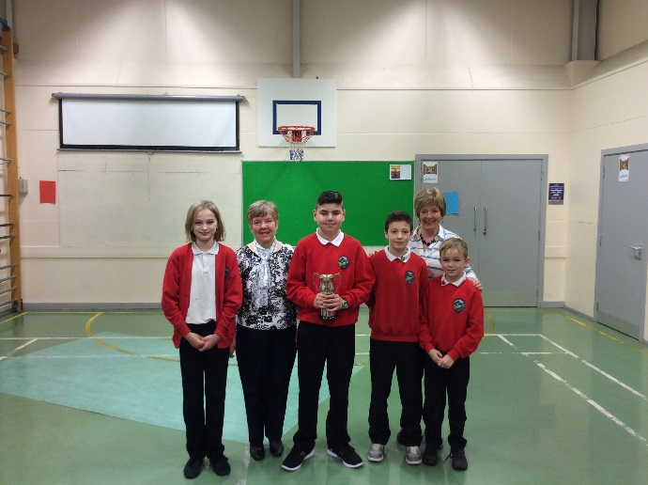  M & M Cup Winner: Luke Dressel for reciting “Jammyside-doon day” by H. A. Harrower.” Very well done, Luke!  Emilie Gray was second with “The Pairtin o’ the wyes” by Joyce Everill and Dylan Carroll and Craig Beverley were third with “Ocht Dad” by William Johnston.  Twitter  Alehousewells school is now on Twitter! Please follow us to see examples of the children’s learning. We are @Alehousewells.  Outside play equipment  We are delighted that Aberdeenshire Council is going to replace our wooden play equipment at the back of the school before the new financial year in April. The Task Force was involved in organising the vote to see which of the four choices was the most popular. The winning design can be seen in the window near the back door of the school. We are all excited and really looking forward to the new equipment coming.  Parents’ evening change of date  We have had to change the date of the forthcoming Parents’ evening from Thursday 23 March to Wednesday 22 March, still from 4-8pm. We hope this isn’t too much of an inconvenience for you, but if you are unable to attend on this new date, we will do our best to accommodate you at another time and day that suits.  PJ Disco reminder – Thursday 9th February  P1 – 3 – 6.30 – 7.30 (doors open 6.20pm)  P4 – 7 – 7.35 – 8.50  Tickets £2.50 – on sale 8th & 9th February at breaktime, to include snack and juice. Glow sticks are on sale at £1 each at the Disco.  Staffing news  After 21 years working for Aberdeenshire Council, the last 10 being at Alehousewells school, one of our cleaners, Brenda Anderson, will retire on 24 February. Also, Katrina Thom, who has worked for 21 years with the Service, will retire at the Easter holidays from working in the kitchen. We thank them for their many years of dedication and commitment to Alehousewells school and wish them both many happy, healthy years in their retirement.  Mrs Alison Ross, PSA, continues to be off ill, so Mr Alexander Esson has been working as a relief PSA in her absence.  Alehousewells school is 40!  This year, Alehousewells school celebrates its 40th birthday! We hope to have a year of celebrations so hopefully there will be something that you can enjoy and attend.  The first event is a Bingo night at the school on Friday 3 March. Doors open at 6pm with eyes down at 6.30pm. More information will follow soon about this event.  Then there is a Quiz night at the Golf Club on Friday 17 March, 7.30pm. Teams can have up to 6 people, and tickets are available from the School Office at £5 each.  All money raised goes towards buying new resources and experiences for all the children at Alehousewells.  Book Fair Arrangements  Our Book Fair will arrive on Wednesday 22nd February until Wednesday 1st March. If you could help to run this event, please let us know by contacting the office or returning the attached slip. We will be looking for a number of parent helpers to make this event a success on Thursday 23rd and Friday 24th, when the children will preview the books, as well as on Monday 27th and Tuesday 28th, when the children are buying books.  World Book Day  World book day is on Thursday 2nd March. As usual, we will have £1 book tokens for each child which will be handed out nearer the time. On Tuesday 28th February, we will have a book theme across the school. Children will be working with different groups and teachers over the course of the morning, and then sharing some of their learning at Assembly that afternoon.  Emergency Contact Updates  Please remember to keep us updated if you change your mobile number. It is vital that we have the latest contact details so we are able to contact or text parents/carers when need be. There is an area to the left of this newsletter for updates.
Spare clothes  If you have any spare clothes (pants, socks, tights, trousers etc) that we could have in case of accidents, we would be delighted to have them, particularly for the younger children. We did have a stock, but it has slowly dwindled away. We would be obliged if your child is given spare clothes to wear from us, that they be washed and returned when you have time.  We also seem to be running short of ice packs so, again, please return these if your child has been sent home with one. It is Amnesty time, no questions asked, as long as they are returned!!  School closure days  Please remember that school is closed this Friday, 10th, as well as Monday 13th, Tuesday 14th and Wednesday 15th February, for Mid-term holidays and In service days.  After School Cooking Classes  Garioch Community Kitchen is offering a six week healthy, fun cookery class running on Tuesdays or Thursdays 4-6pm. To book spaces email: gariochcommunitykitchen@hotmail.co.uk or phone: 07729 297892  Yours Sincerely,  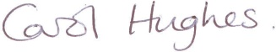  Carol Hughes  HEAD TEACHER  _____________________________________________________________  You are invited to comment on the return pro-forma on any aspect of school whether as a comment/ suggestion, compliment or concern. These are responded to as and when necessary.  Comment/Suggestion, Compliment or Concern, February 17  ______________________________________________________  ____________________________________________________________________________________________________________  My name_______________________________________________  My child’s name and class _________________________________  I can help with the Book Fair on 23rd/24th/27th/28th February. Please indicate which days and times you can manage. Many thanks.  Name________________________________  Child’s name__________________________Class____________  Thurs 23rd Feb Preferred Times_____________________  Frid 24th Feb Preferred Times_____________________  Mon 27th Feb Preferred Times_____________________  Tues 28th Feb Preferred Times_____________________ |  | Friday 31 Mar – Last day of term. Church service, 10am.  Tuesday 18 Apr – Back to school. P7 leave for Dalguise, 9.30am.  Friday 21 Apr – P7 return from Dalguise, 4.30pm.  Tuesday 25 Apr – Parent Council meeting, 6.30pm, all welcome.  Monday 1 May – School closed for May Day.  Monday 22 May – Sports’ Day  Monday 29 May – Sports’ day reserve date.  Tuesday 30 May – Parent Council meeting, 6.30pm, all welcome.  Monday 5 June – School closed for Local holiday.  Thursday 8 June – Shorts & shades disco – P1-3 6.30-7.30, P4-7 7.35-8.50.  Friday 9 June – Folder of work home today  Wednesday 21, Thursday 22 & Friday 23 June – P7 Link days at Kemnay Academy  Thursday 22 June – Meet your new teacher.  Thursday 29 June – Dress as you please day. Talent Show.  Friday 30 June – Last day of the session. Church service, 10am, all welcome.  Tuesday 22 Aug 2017 – P2-7 back to school.

