 | Alehousewells School  Newsletter 11 | March 2017
Alehousewells School  Bremner Way  Kemnay  AB51 5FW  Tel: 01467 642247  Fax: 01467 642040  Emergency Phone line 0870 054 4999, Pin no. 021180  alehousewells.sch@aberdeenshire.gov.uk  Head Teacher:  Mrs Carol Hughes  Emergency Contact Details Update  Childs Name:  _____________________  Class:________________  Emergency Contact:  Name:________________  Number:______________  Address:________________________________________________________  Diary Dates:  Friday 3 Mar – Bingo Night, 6.30pm.  Friday 17 Mar – Folder of work sent home today, Quiz night at the Golf Club, 7.30pm  Monday 20 March – Reports issued  Wednesday 22 Mar – Parents’ night, 4-8pm. More information to follow.  Friday 24 March – Comic Relief, more information to follow.  Thursday 30 Mar – Dress as you please day.  Friday 31 Mar – Last day of term. Church service, 10am.  Tuesday 18 Apr – Back to school. P7 leave for Dalguise, 9.30am.  Friday 21 Apr – P7 return from Dalguise, 4.30pm.  Tuesday 25 Apr – Parent Council meeting, 6.30pm, all welcome.  Monday 1 May – School closed for May Day.  Monday 22 May – Sports’ Day  Monday 29 May – Sports’ day reserve date.  Tuesday 30 May – Parent Council meeting, 6.30pm, all welcome.  Monday 5 June – School closed for Local holiday.  Thursday 8 June – Shorts & shades disco – P1-3 6.30-7.30, P4-7 7.35-8.50.  Friday 9 June – Folder of work home today  Wednesday 21, Thursday 22 & Friday 23 June – P7 Link days at Kemnay Academy  Thursday 22 June – Meet your new teacher.  Thursday 29 June – Dress as you please day. Talent Show.  Friday 30 June – Last day of the session. Church service, 10am, all welcome.  Tuesday 22 Aug 2017 – P2-7 back to school. | Dear Parents/Carers,  Here we are already into March, so there are several items I would like to share with you.  Welcome  Welcome to Alanna and Elisha Davidson, and Ellie and Kallum Mitchell who joined P2, P5, P1 and Nursery last week. I hope you will all settle into life at Alehousewells school very quickly and enjoy being part of our school.  PJ Disco  Many thanks to the DJs who did a great job at our recent PJ disco. They were: Rebecca, Faith, Rhys and Kelsey. Also, my thanks go to the staff and parents who helped on the night. Again, without volunteers, these Discos could not happen.  Dlite Student in P6 and PGDE Student in P2  Last week, a PGDE Primary teaching student, Mrs Thain, joined P2 and next week, a Dlite Primary teaching student, Mr Esson, joins P6 for a few weeks, before returning again for a spell after Easter.  Book Fair  This, as usual, was a huge success, although we are still to hear how much commission we raised for the school, which we will spend on Library books. I would like to thank the parents who ran this for us. Without your help, these events would not be able to go ahead.  Winners of the Book Fair Class Competitions:  Nursery: Brogan Alexander, Jade Lee and Samantha Thorburn  P1: Morven Low  P2: Katie Torrance  P3: Freddi Laing  P4 Liam Strachan  P5: Josh Mackland  P6: Emilie Gray  P7: Aaron Jones  They all received a book from the Book Fair for their efforts.  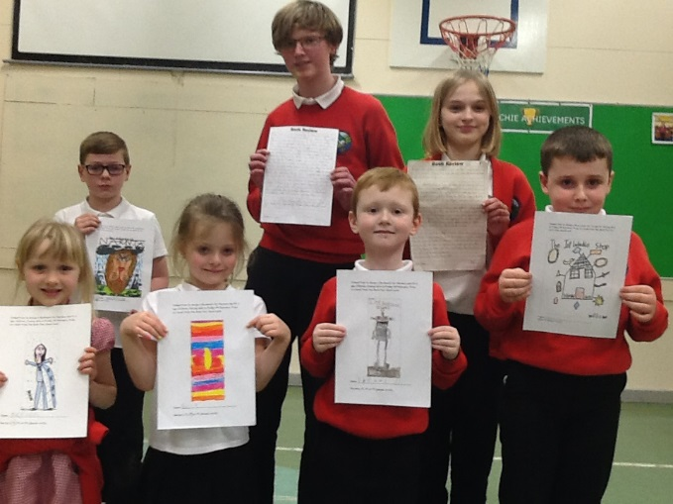  World Book Day Fun Activities  We had a lovely morning celebrating World Book Day on Tuesday with a range of book related activities, and then enjoyed shared our learning with everyone in an Assembly in the afternoon.  School website now live!  Our school website is now live! Thank you for your patience while we waited for Aberdeenshire Council to update it. I hope you will find it a useful place to visit, e.g. for Newsletters.  www.alehousewells.aberdeenshire.sch.uk  Twitter  Please follow us on Twitter! You will find us at @Alehousewells.  P7 Rotary Quiz  This week, five of our P7 pupils, Hugo Freeman, Andrew Morrison, Aaron Jones, Kirsten Whyte and Erin Charles represented Alehousewells School at the annual Primary Schools Rotary Quiz at Kintore Primary. Though we didn’t win, our P7’s represented the school extremely well. Well done team Alehousewells!  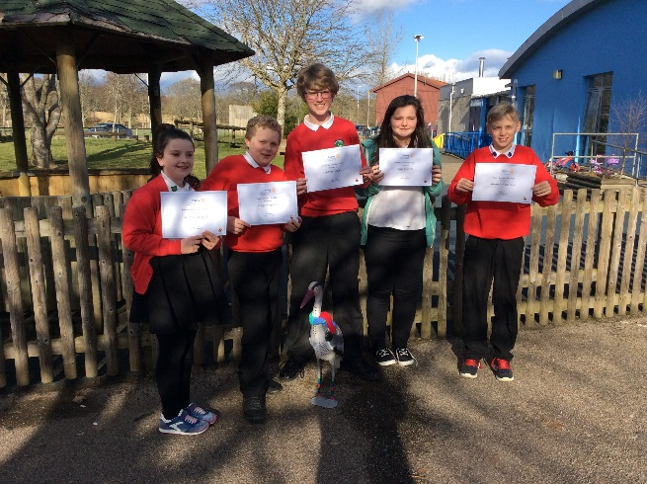  Dog fouling  Recently, I have been made aware of an increase in dog fouling in the area around the school. Some of these relate to the pavement outside the school while others relate to the area around the car park on Waterside Court area adjacent to the school. It is also a problem in the school playground. Please ensure that if you are a dog owner, you are a responsible one, and keep our school environment safe and hygienic. Thank you.  Comic Relief red noses  We are selling Red Noses in school for £1 for Comic Relief, first come first served! The Task Force are helping me with a theme for that day so I will let you know once that has been decided.  SSPCA donations  Many thanks to everyone who has handed in items for the SSPCA which were collected recently for their Animal centre at Drumoak. They accept:  - Newspapers  - Old towels/blankets (no pillows or duvets)  - Any kind of Unopened Animal food/treats - they particularly struggle to get enough puppy/kitten food and also food for animals with sensitive tummies (usually chicken flavours are good, chappie dog food etc)  - Good condition toys, collars, harness & leads  - Animal bedding  They care for a variety of animals at Drumoak including dogs, cats, rabbits, ferrets, small furries, birds, reptiles and horses just to name a few so any items are greatly appreciated.  We still have a collection box in the Office, so please drop off any donations and we will pass them on to the SSPCA.  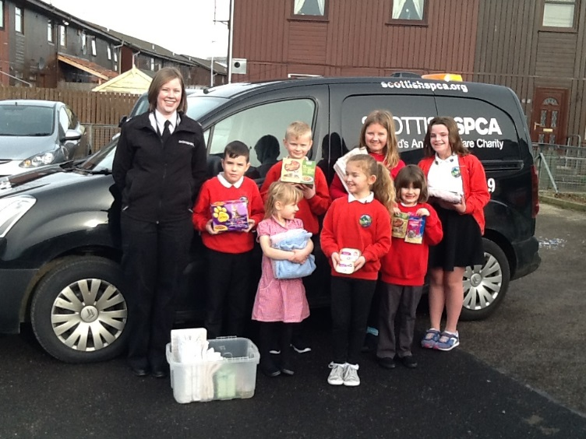  Free School Meals  If you think your child may be eligible for Free school meals, please either call 08456 080149, email benefits@aberdeenshire.gov.uk or ask for a leaflet from our school Office.  Free eye examinations  We have been asked to share this information with you:  All children in Scotland are entitled to an annual free eye examination by a qualified Optometrist (Optician). These examinations are really important for checking the health of your children’s eyes and for making sure that children get any help they may need to make the most of their vision.  Sometimes children do not notice that one eye cannot see as well as the other and an eye examination can check to see if your child has any squints or ‘lazy eyes’ or if they need glasses. Vision can change over time so it is important to have checks regularly to see if there has been any change.  The Optician will give a prescription for glasses for your child if they need it. There is no obligation to buy glasses from the same Optician. Your child is entitled to an NHS optical voucher to help cover the cost of glasses. If the glasses you choose costs more than the voucher, you will have to pay the difference. The Optician will explain this in more detail.  We would encourage all parents to take their children to any high street Optician for regular eye examinations whether or not they think they may need glasses.  Kemnay Community Learning & Development  - Want to improve your Reading, Writing & Numbers?  - Want to get a better job?  - Is English not your first language?  - We can help you:  Gain confidence  Help children with school work  Write letters or CVs  Fill in forms and timesheets  Find a new job  Understand bills or labels  Learn English  Aberdeenshire Council Community Learning and Development supports adults to improve their reading, writing and numbers. We also support adults whose first language is not English.  For more information Contact Caithleen Bell (Community Learning & Development Worker) 01467 539 853 or 07557 171 907  Bingo Night/Quiz Night  Family Bingo Night is tomorrow (3 March 2017) – Door open at 6.00pm – eyes down at 6.30pm - £2 Adult & £1 OAP/Child. Tickets still available from the school office. Please enter via the Community lounge/Blue Nursery door.  Quiz Night is 17 March 2017 at the Golf Club. Meals are served from 5.30pm and quiz will start at 7.30pm – Wear something green for St Patricks Day – Tickets cost £5 per adult from the school office. You may enter up to 6 people per team. Get your teams entered ASAP to avoid disappointment!  Reporting  The week after next, your child will be working in their Home/School folder, which they will take home on Friday for you to look through. The purpose of this is so that you can see the quality and variety of work that your child may do in any week at school, and use this as an opportunity to discuss their learning with your child. This is the second time this session, the next being in June. Of course, not every piece of work can be represented in their folder e.g. work done orally. We would welcome any comments you may have each time the folder goes home, so please do so in the relevant box. Then please sign at the bottom of the box and ensure that the folder is returned the following Monday. There will also be a new sheet included, asking for you to tell us if your child attends any clubs or has any interests out of school. This is so that we can track out of school achievements.  Staff are also currently working on the written reporting format we issued for the first time last session. Reports will be issued to parents and carers on Monday 20 March, with Parents evening on Wednesday 22 March, from 4pm. We would like to again involve the children in these meetings, so that they can speak about two pieces of work they have done which they are proud of. We tried this for the first time last year and we received positive feedback about doing the meetings this way. Further information about this evening and the format will be issued with the report.  Yours Sincerely,  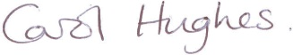  Carol Hughes  HEAD TEACHER  _____________________________________________________________  You are invited to comment on the return pro-forma on any aspect of school whether as a comment/ suggestion, compliment or concern. These are responded to as and when necessary.  Comment/Suggestion, Compliment or Concern, March 17  ______________________________________________________  ____________________________________________________________________________________________________________  My name_______________________________________________  My child’s name and class _________________________________

