Alehousewells School
Newsletter 13
April 2017
Alehousewells School  Bremner Way  Kemnay  AB51 5FW  Tel: 01467 536910  Emergency Phone line 0870 054 4999, Pin no. 021180  alehousewells.sch@aberdeenshire.gov.uk  Head Teacher:  Mrs Carol Hughes  Emergency Contact Details Update  Childs Name:  _____________________  Class:________________  Emergency Contact:  Name:________________  Number:______________  Address:________________________________________________________  Diary Dates:  Monday 1 May – School closed for May Day.  Wednesday 3 May – P1 & P7 class photos, pm.  Tuesday 9 May – Celebration Assembly, p.m.  Wednesday 10 May – Netball festival  Thursday 11 May – P5 Cluster ceilidh  Monday 22 May – Sports’ Day  Monday 29 May – Sports’ day reserve date.  Tuesday 30 May – Parent Council meeting, 6.30pm, all welcome.  Monday 5 June – School closed for Local holiday.  Tuesday 6 June – Netball festival  Thursday 8 June – Shorts & shades disco – P1-3 6.30-7.30, P4-7 7.35-8.50.  Friday 9 June – Folder of work home today  Wednesday 21, Thursday 22 & Friday 23 June – P7 Link days at Kemnay Academy  Thursday 22 June – Meet your new teacher, 11-12.  Tuesday 27 June – Talent Show & House 40th birthday party. | Dear Parents/Carers,  Welcome back to this last, but very busy, term. Hopefully you all had a lovely holiday and are refreshed, recharged and raring to go! The weather wasn’t great but hopefully it didn’t spoil the holidays for you.  Welcome to Derren Wilson who joined P3 and Mrs Mairi MacDonald who started in the Red and Yellow Nursery as an Early Years Practitioner, covering while Mrs Montgomery is on Maternity leave, last week. I hope you will both settle into life at Alehousewells school very quickly and enjoy being part of our school.  Teaching students  We welcome back Mrs Thain in P2 next week and Mr Esson in P6 the following week for their next teaching practise block.  Sun cream  With the better weather hopefully coming, please ensure your child has appropriate cover e.g. sunhat and sun cream. We are not able to apply lotion to the children so please ensure sun cream is applied at home before coming to school.  Class photos  All the Primary 1’s and 7’s will be getting their class photo taken in the afternoon of Wednesday 3rd May. We would appreciate if the children could be in their full school uniform, thanks.  P 4-7 Netball Festival  Good luck to everyone in P4- 7 who will soon take part in the Inverurie Netball Festival on Wednesday 10 May. They have worked hard all year on their skills so this is an ideal way to put these into practise and show their sportsmanship.  P5 Ceilidh  P5 will soon be attending the Kemnay Schools Ceilidh for all P5s, this year to be held at Kintore Primary. This is part of the transition process from Primary to Secondary school and is always a fun event.  SSPCA  Many thanks to everyone who contributed to the end of term collection at Church for our Charity of the year, the SSPCA. We raised £72.48.  Rebecca Henderson in P7 has been making and selling Loom bands at school and has made £54.12 so far for the SSPCA. She will continue to sell them this term every Tuesday playtime.  The Task Force has agreed that the above money, along with any further money raised this term, will go towards sponsoring an animal pen at the SSPCA centre in Drumoak. This could be for a dog (£95), cat (£65), horse (£135), rabbit (£45) or small animals eg Guinea pigs (£40), depending on how much we raise.  We still have the collection box at the office for donations of pet food, towels, blankets, pet toys or newspapers for the centre at Drumoak.  School website now live!  Our school website is now live! Thank you for your patience while we waited for Aberdeenshire Council to update it. I hope you will find it a useful place to visit, e.g. for Newsletters.  www.alehousewells.aberdeenshire.sch.uk  Skype (telephone)  We now have a new telephone number as we move to a new Skype system. Please start using this new number – 01467 536910. You will then be given the choice to either report an absence or speak to a member of the Admin Team.
Twitter  Please follow us on Twitter! You will find us at @Alehousewells.  Bingo night and Quiz night proceeds  With the proceeds from these two fundraisers, we have bought a Kasbah, a new listening centre and speaker that we can use outside for playing music at lunchtimes.  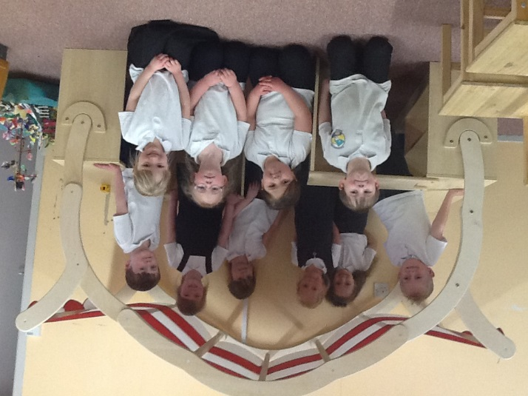  Kemnay Breakfast & After School Club  Kemnay Breakfast Club are looking to recruit a Manager, please see our notice-board for more information or contact the chairperson at: kemnayasbc@gmail.com  Xpressions  Just a wee reminder to register for Xpressions if not already done so. This is a great way to keep up to date with news from school. Xpressions is an App which enables schools to share certain elements from their MIS data instantly and securely with parents on their smartphones or tablets and is very user friendly.  New bins  We are delighted that our 4 new bins for our playground are now in place. They have brightened up the playground and are doing a grand job in encouraging everyone to keep our playground tidy.  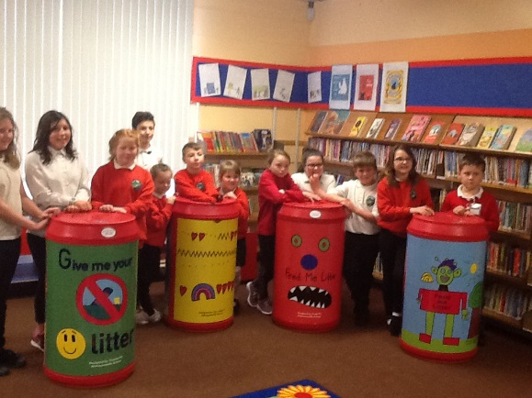  Sports Day  Sports Day is planned for Monday 22 May, with a reserve date of the following Monday, 29 May.  Potted Sports are held in the morning, with each of the three Houses, Don, Fraser and Bennachie, further divided into four teams, making twelve teams in total. Each team is given a country to represent. Each team has a mixture of pupils from P1-7. Potted Sports starts at 9.45 and all parents are very welcome to come along and watch their child(ren) as they try activities like Hockey slalom, Football dribble or Hoop run.  In the afternoon, we have traditional races, starting at 1.45. All are welcome to come along. There will be some chairs and benches set out for spectators but you are welcome to bring chairs or a blanket to sit on of your own.  At the end of the afternoon, the children are treated to an ice lolly courtesy of the Parent Council.  This year again, we are asking if each pupil would try and wear something in their House colour so as to promote more of a House competition, as the House that accrues the most points on Sports Day wins the House Sports Shield. Fraser is red, Don is blue and Bennachie is green. The results will be announced to the children at Assembly on Tuesday 6 June.  Outside play equipment  We are delighted that our new outside play equipment has been installed. The children are loving playing on it.  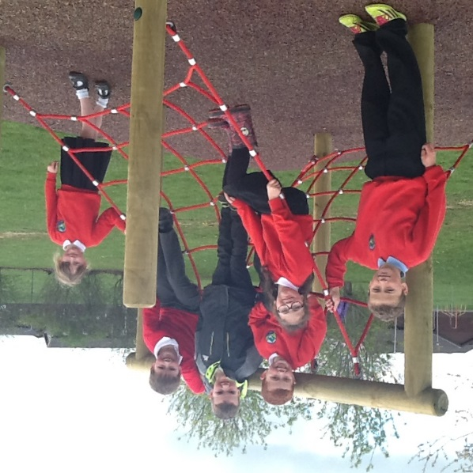  Achievements  Emily Stewart P4 won the rotary photography competition and now gone into the Scottish finalists! Good luck to Emily!  We are having another Celebration assembly on Tuesday 9 May so please let us know if there is anything that your child is proud of that they could share with us on that day.  Yours Sincerely,  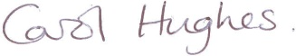  Carol Hughes  HEAD TEACHER  _____________________________________________________________  You are invited to comment on the return pro-forma on any aspect of school whether as a comment/ suggestion, compliment or concern. These are responded to as and when necessary.  Comment/Suggestion, Compliment or Concern, April 17  ______________________________________________________  ____________________________________________________________________________________________________________  My name_______________________________________________ |  | Wednesday 28 June – Nursery family fun day.  Thursday 29 June – Dress as you please day.  Friday 30 June – Last day of the session. Church service, 10am, all welcome.  Tuesday 22 Aug 2017 – P2-7 back to school.

