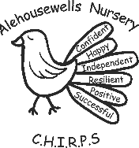
Alehousewells
Nursery
Supporting
Positive Behaviour
Policy
Date - February 2019 Review Date - March 2020 Authors – Sarah Bergin and Michelle Morrison.

Alehousewells School aspires to be a safe and supportive learning community where everyone is respected and can realise their full potential within a friendly and caring environment.

At Alehousewells nursery our vision and values are:
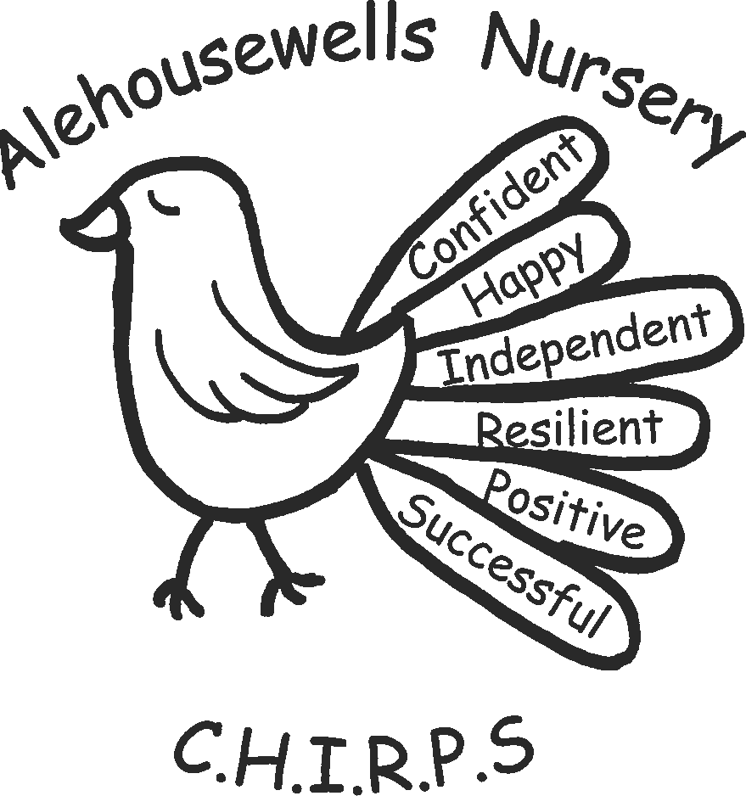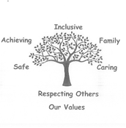

In nursery we aim:

- To create a welcoming, homely, safe and secure learning environment where everyone is committed to stimulate curiosity, resilience and a desire to learn through play and new experiences.
- To build confidence and independence to enable our children to make good choices and develop skills for life.
- To provide a curriculum which is responsive to the individual needs and interests of the children.
- To support the children’s understanding and development so that they can achieve their best.
- To foster a community based upon caring relationships, respect for each other and our environment, in which all children and adults are treated equally and fairly.
- To provide a nurturing environment for children and their families.

At Alehousewells Nursery we take a positive approach to all aspects of behaviour as part of our vision, values and aims. Getting it right for every child ensures that anyone providing support puts the child and family at the centre. As stated in The United Nations Convention on the Rights of the Child (UNCRC) – (1989):
Article 39: (Recovery from trauma and reintegration) Children have the right to help if they have been hurt, neglected or badly treated.
Article 12: (Respect for views of the child) Children have the right to give their opinion, and for adults to listen and take it seriously.

Through this the children are supported as they grow and develop into;
- Successful learners
- Confident individuals
- Effective contributors
- Responsible citizens
We believe that promoting positive behaviour within the group will lead to better co-operation between children. It will foster a caring attitude and help children develop a sense of responsibility both for themselves and others.
Each child is treated individually and will be praised for achievements at their own level, both in play and with regards to behaviour.
How do we encourage Positive Behaviour?:
- Ensure that expectations are developmentally and age appropriate.
- Praise, reward and acknowledge positive behaviour.
- Staff to act as positive role models for the children
- Our routines are visible and interactive for the children.
- We use stories, songs and together time to discuss behaviour.
- We listen and ask questions to understand the reason for challenging behaviour to find out what will help.
- Staff to always speak clearly to children, at the child’s eye level.
- Staff to be fair and consistent in their dealing with behaviour management issues.
- The use of learning contexts to aid children to achieve success thus promoting a positive self-image, but also allow for challenge.
- Children, staff and families to be involved in the reviewing of the behaviour policy.
- Staff are aware of national policy and guidance
- Scottish Government, 2013, "Better Relationships, Better Learning, Better Behaviour " https://education.gov.scot/parentzone/Documents/BetterRelationships.pdf
- Scottish Government, 2017,"Included, Engaged and Involved Part 2: A Positive Approach to Preventing and Managing School Exclusions" http://www.gov.scot/Resource/0052/00521260.pdf
- Scottish Government, 2012, "Getting it right for children and families: A guide to Getting it right for every child" www.scotland.gov.uk/gettingitright http://www.gov.scot/Resource/0045/00458341.pdf
- Education Scotland, 2016, “How good is our early learning and childcare?” https://education.gov.scot/improvement/documents/frameworks_selfevaluation/frwk1_niheditself-evaluationhgielc/hgioelc020316revised.pdf
- Scottish Government, 2017, “Health and Social Care Standards My support, my life” www.gov.scot/Publications/2017/06/1327
- Scottish Government, 2014, "Building the Ambition: National practice Guidance on Early Learning and Childcare Children and Young People (Scotland Act)” http://www.gov.scot/Resource/0045/00458455.pdf

- Staff are aware of Aberdeenshire policy and guidance
- Aberdeenshire Council, 2007, “Guidance for Schools and Community Schools Networks: “Working together” to Support Children, Young People, and Staff Promoting positive behaviour. https://www.aberdeenshire.gov.uk/media/12213/promotingpositiverelationships.pdf
- Health and Social Care Standards:
- 1.1 I am accepted and valued whatever my need, ability, gender, age, faith, mental health, status, race, background or sexual orientation
- 1.29 I am supported to be emotionally resilient, have a strong sense of my own identity and wellbeing, and address any experiences of trauma or neglect.
- 2.8 I am supported to communicate in a way that’s right for me, at my own pace, by people who are sensitive to me and my needs
- 2.15 I am enabled to resolve conflict, agree rules and build positive relationships with other people as much as I can. http://www.gov.scot/Resource/0052/00520693.pdf
At Alehousewells we believe that positive feedback, interactions and encouragement is the best way to promote positive behaviour and minimise challenging behaviour/situations. Our policy is to be open and honest with parents, working together through any situations which may arise. As part of a child’s initial settling in period, staff will meet with parents to discuss the child’s wellbeing and create a behaviour support plan if necessary.
Although we encourage positive behaviour, we are aware that at times some children may not be able to adhere to this. The following system is in place to deal with this occurrence:
- A child will receive two clear verbal warnings from staff, which should include an explanation as to why their behaviour is unacceptable.
- If this is unsuccessful, the child will be asked to leave the activity. Staff will direct the child to another activity and if deemed necessary an adult would accompany them and talk to them about the behaviour.
- Should the child repeat the behaviour the above action would be repeated once more.
- Staff would record incidents deemed more serious using the incident sheets which are kept in the first aid folder in the medication cupboard. The sheets would then be stored in the child’s personal file. This should also be reported to the Lead Practitioners. If necessary, this would also be recorded in the behaviour support plan. This would assist staff to identify any triggers to the behaviour and think about how best to support the child to successfully move on from this.
If a child persistently displays behaviours that concern staff, then the Nursery Senior or Lead Practitioners will contact the child’s parent/ carer and discuss their concerns with them. A support plan will be created on how best to support the child going forward. This will be discussed as a team and with the parent to ensure continuity for the child. The child’s Behaviour Support Plan will be kept in the child’s ‘All About Me’ folder and will be reviewed regularly.
If staff feel they require further support, other agencies such as Educational Psychologist, SALT etc may be contacted or guidance.

Alehousewells Nursery staff will ensure confidentially is always respected.
Alehousewells Nursery staff will continue to attend training on Promoting Positive Behaviour.

