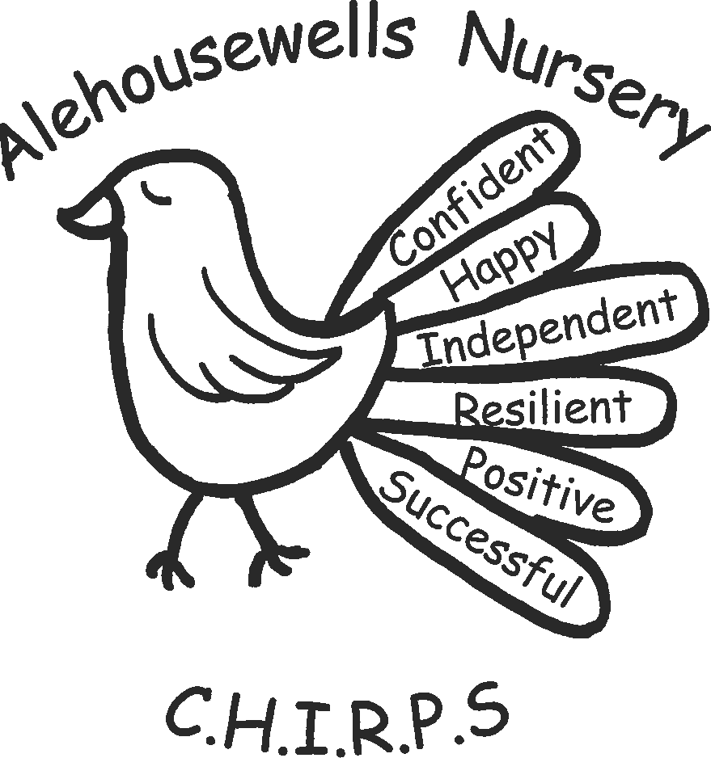

Curriculum Policy

Date: March 2019 Review Date: March 2020 Author: Sarah Bergin

Curriculum Policy

At Alehousewells Nursery we aim to:

- To create a welcoming, homely, safe and secure learning environment where everyone is committed to stimulate curiosity, resilience and a desire to learn through play and new experiences.
- To build confidence and independence to enable our children to make good choices and develop skills for life.
- To provide a curriculum which is responsive to the individual needs and interests of the children.
- To support the children’s understanding and development so that they can achieve their best.
- To foster a community based upon caring relationships, respect for each other and our environment, in which all children and adults are treated equally and fairly.
- To provide a nurturing environment for children and their families.

Curriculum for Excellence

The “Curriculum for Excellence aims to achieve a transformation in education in Scotland by providing a coherent, more flexible and enriched curriculum for 3 to 18 year olds.
The curriculum includes the totality of experiences which are planned for children and young people through their education, wherever they are being educated.”
(Learning & Teaching Scotland).
The purpose of the Curriculum for Excellence is to enable each child to become a successful learner, a confident individual, a responsible citizen and an effective contributor.

Curricular Areas
Learning experiences cover each of the curricular areas: Health and Wellbeing, Literacy, Numeracy, Expressive Arts, Social Studies, Religious and Moral Education, Science and Technology.
Literacy
To support Literacy we are using Highland Council’s Emerging Literacy Developmental overviews to find out the children’s strengths, so that we can extend them, as well as identify where they might need some more help.
Numeracy
Our understanding of schemas encourage staff to think about mathematical concepts and language when they are providing and interacting with children. This is also supports staff observations.
Health and wellbeing
Our free flow to the outdoors and wide use of the community supports the children’s health and wellbeing. The wide range of open ended resources on offer encourages resilience and fine/gross motor skills.
Principles
Carefully planned learning experiences provide challenge and enjoyment, breadth, progression, depth, personalisation and choice, coherence and relevance.
The Purpose

The purpose of our curriculum at the early level is to support children in all aspects of their emotional, social, cognitive and physical development. It should enable them to become increasingly independent, responsible and eager to progress in their learning.
Our Staff will help to achieve this through skilled interactions with each child and by providing stimulating contexts for active learning, by recognising each stage of development and building upon the child's knowledge and skills.

An Environment where:

- The children are fully engaged in their learning, which is interactive, purposeful and defined within the outcomes and experiences.

- The learning environment is relaxed and supportive with opportunity for observation, interaction and further exploration of interests and activities.

- The learning environment is imaginatively resourced and stimulating, with opportunity for engagement in exploratory and spontaneous play.

- The imaginative use of space and resources which creates opportunity for children to work independently or collaboratively.

Staff who:

- Are open, positive, and support relationships in which children will feel that they are listened to

- Promote a climate in which children and young people feel safe and secure

- Model behaviour which promotes effective learning and wellbeing

- Are sensitive and responsive to each child’s wellbeing.

Children should be encouraged to contribute to the life and work of the nursery. This includes opportunities to participate responsibly in decision making, to contribute as leaders and role models, to offer support to others and to play an active part in putting the values of the nursery community into practice. Staff will use the experiences and outcomes at the early level to plan coherently for progression in learning across the curriculum.
Pre Birth to Three
Pre-Birth to Three: Positive Outcomes for Scotland’s Children and Families is a document introduced by the Scottish Office, in association with Learning and Teaching Scotland to provide guidance for all those whose work, involves caring for babies and young children. The four key features of Pre-Birth to Three are closely linked:
- Rights of the Child
- Relationships
- Responsive Care
- Respect
Our nursery staff work very closely with the Pre-Birth to Three documents to provide the quality experiences children under 3 years need.
Learning at this stage involves providing opportunities to play, interact, explore, create and to problem solve. We support this by providing a safe, fun, and challenging environment with staff which allow us to
- Support our children’s immediate interests and needs
- Develop relationships which encourage children to participate actively
- Create opportunities for children to communicate their feelings and their thoughts.
Additional Support Needs
At Alehousewells Nursery inclusion as an entitlement for all our service users and we strive to create a secure and accepting environment which will recognise and value diversity. Inclusion as a matter of entitlement and equal rights as stated in the UN Convention on the Rights of the Child, the European Convention of Human Rights and in National Legislation.
The Education (Additional Support for Learning) (Scotland) Act 2009 is underpinned by the theme of equality. It requires establishments, local authorities and other agencies to address additional support needs which may arise during the course of a child/young person’s education. It legislates that it is everybody’s responsibility to ensure that support is directed towards enabling children to become successful learners, a confident individual, responsible citizens and effective contributors.
We believe that our staff have a responsibility to contribute to the experiences and outcomes within Literacy, Numeracy and Health and Well Being. A child who is safe, healthy, accepted, nurtured, achieving, respected, responsible and included will benefit more from the educational experiences and outcomes on offer.
Using Scottish Governments agenda “Getting it right for every child”, promotes integrated working, sharing information and actions to meet a wider range of support needs and promote wellbeing.
Aims:
- To ensure all children’s individual needs are met to meet their full potential.
- To provide support and guidance and work in partnership with all parents, in the identification, assessment and delivery of additional support for learning.
- To strive for close co-operation and partnership between all agencies concerned.
- To ensure staff will further support children through continuity, appropriate planning and effective use of available resources eg Makaton, visual timetable, symbols, PEC’s. To ensure staff provide support and guidance to parents through parental involvement and partnership.
- To take into account the parent’s knowledge of their own child.
- To strive for close co-operation and partnerships between parents and all agencies involved.
- To provide staff with the appropriate training and to keep staff up to date with current legislation.
- Where a child has additional support needs a plan of action(Personal Passport) is required to outline:
- The triggers or factors affecting the child’s educational attainment / achievement
- The aims and outcomes
- Support required to meet the child needs
- How this support will be used
- The roles and responsibilities of all involved.

Planning may be short term or long term depending on a child’s circumstances.
There are several ways in which we plan to meet the needs of our children in our setting. These include:
- Forward planning for the class/playroom
- Care plans
- Personal passport and sensory passport
- Multi Agency plan
- Individual Education Plan(IEP)
- Co-Ordinated support plan(CSP)

We constantly review the adequacy of support for all pupils working closely with the child and their family and have responsibility for monitoring and reviewing a personal support passport. Where support is agreed from external agencies, we will work in partnership to support the child. This ensures that Alehousewells nursery is using the wellbeing indicators to ensure we are getting it right for every child.

