Alehousewells Nursery

Information for Parents

Butterfly Room Caterpillar Room

About us

Alehousewells Nursery has been running for 26 years within Alehousewells School. In the beginning we were the only nursery in the village until Kemnay Nursey opened in 2001. We have continued to grow with the addition of another nursery room in 2015, this enabled us to provide 2-year-old provision.
April 2018 saw us being the first setting in Aberdeenshire to provide 1140 hours as part of the Scottish Governments pledge to increase the provision of early learning and childcare. This opportunity allowed us to rebrand our Vision, Values and Aims for the children attending Alehousewells Nursery. This meant purchasing new equipment to enhance the environment which will promote curiosity and resilience.

We are inspired by the natural environment; this has been the driving force behind expanding and developing our outdoor learning. Staff fully understand the benefits of outdoor learning and the first-hand experience this gives the children. As well as daily outdoor play in our garden areas we utilise our local community and visit Fetternear Woods, the Viewpoint, the River Don as well as local shops and cafes.

We strive to create a welcoming, homely and safe learning environment for our children getting it right for every child is at the heart of our practice. One of our core values is parents/ families and taking time to get to know individual children, families and the wider community. As part of our nurturing ethos, we pride ourselves in our open-door policy, where we are always available to listen and support our families. Staff have a wealth of knowledge and work alongside several support services which can be accessed by all.

As a child led learning setting, we encourage children to share experiences and interests. We consult with children and build on their prior knowledge through using significant observations to inform our planning and understand children’s next steps. We encourage parents to share their child’s learning through a variety of ways i.e. parent interviews, inductions, stay and play sessions, planning walls, the children’s Interactive Learning Diary (ILD) and All About Me folders as well as parent/ children evaluation board. Regular parent information letters and our Facebook page is used to communicate with our families.

When developing the children’s experiences and interests we consider the Curriculum for Excellence, How Good is Our Early Learning and Childcare, Building the Ambition, Pre-Birth to 3 and the National Care Standards. Our curriculum is firmly play based with active learning which puts the child at the centre.

As an Aberdeenshire Council setting, we work with the Early Years Development team and our Principal Teacher. Staff have regular opportunities to develop their skills and knowledge by attending regular training as well as establishing links with other Aberdeenshire Council settings where we can share and learn about good practice.

As we are located within a school our children benefit from having good links with the whole school. The children in our nursery will be a valued member of our school community which supports the transitions into primary 1. We trust you and your child will enjoy their learning journey with us and we look forward to sharing their progress and achievements with you.

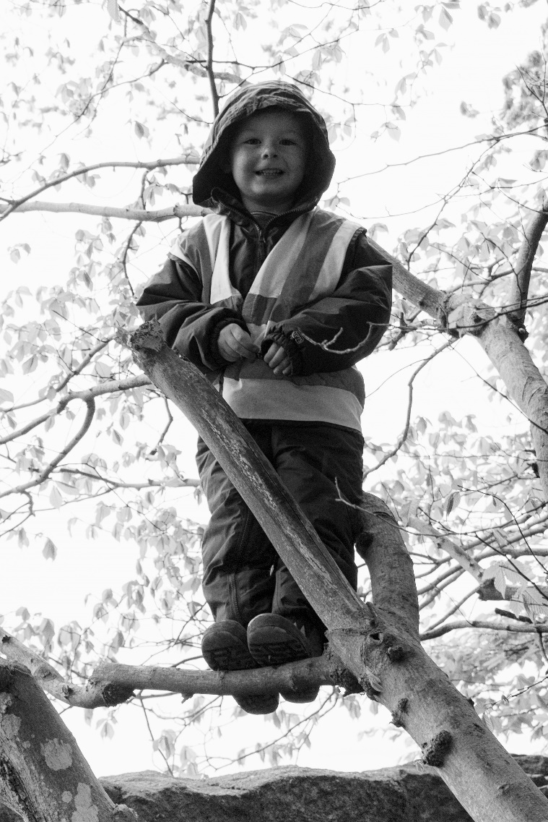

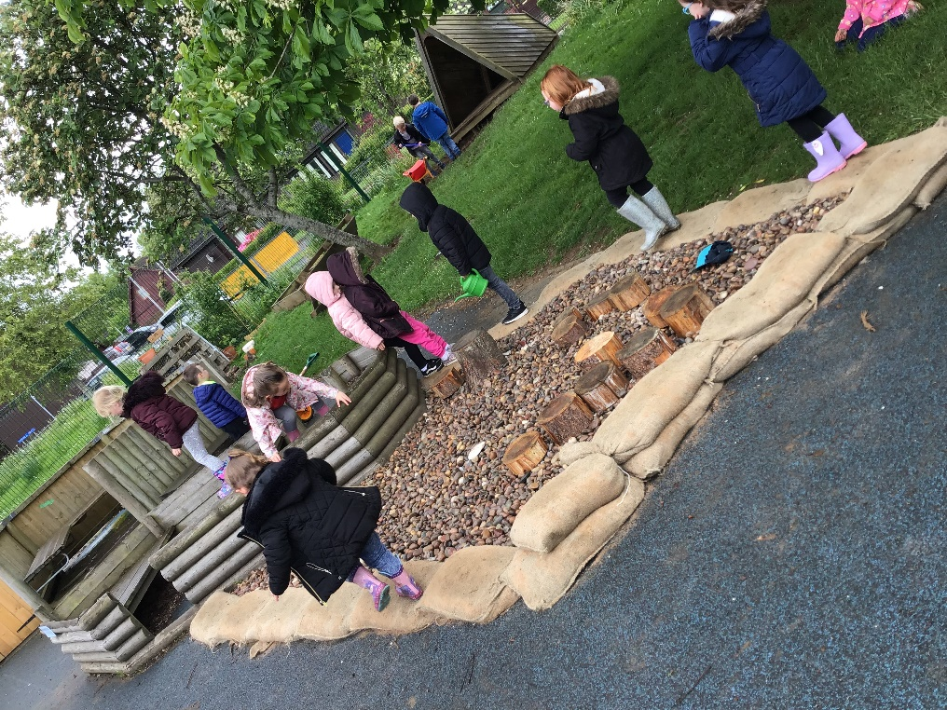
Curriculum – Early Years

Your Child’s Interactive Learning Diary (ILD) is used by staff to record observations and evaluate areas of Early Learning that has been covered. This includes the Curriculum for Excellence, Pre- Birth to 3, Building the Ambition and Wellbeing Indicators (SHANARRI).
You will be able to see what level your child is working at from the colour codes in the observation (red – started to explore, amber – becoming confident, green – achieved).

Early Level Curriculum is accessed from 3 years to the end of Primary 1.

Curriculum for Excellence covers:
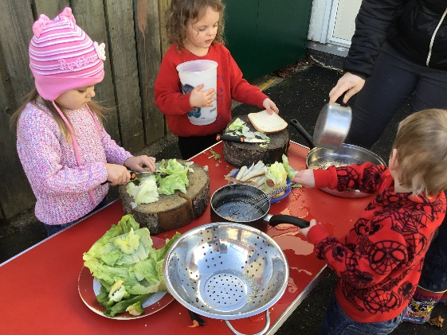
- Numeracy
- Literacy
- Health and Wellbeing
- Science
- Expressive Arts
- Technologies
- RME
- Social Studies

2-year-old children observations are based on the Pre-Birth to 3 curriculum.

Pre- Birth to 3 covers:
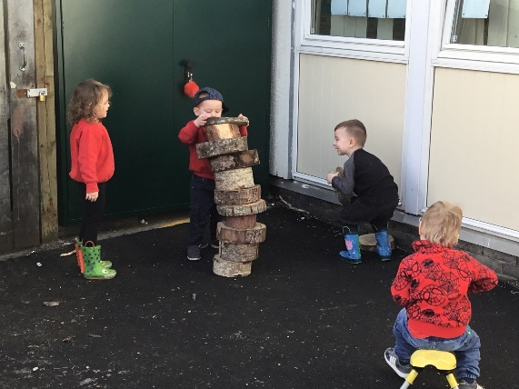
- Rights of the child
- Respect
- Responsive Care
- Relationships

Wellbeing Indicators are used under the guidance of Getting it Right for Every Child (GIRFEC) these indicators are known as SHANARRI. Every child has the right to have these indicators met by all the people who care for them.
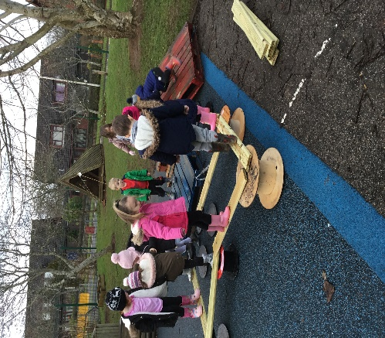
- Safe
- Healthy
- Achieving
- Nurtured
- Active
- Respected
- Responsible
- Included

Facilities

Alehousewells Nursery is attached to the main school building. We have 2 very spacious Nursery classrooms and benefit from using some of the school facilities for gym and music sessions.
We have a fantastic outdoor space, which is accessed on a free flow basis daily. We provide daily opportunities for outdoors learning and energetic play. We ask that children come dressed for all weathers, so that they can take part in all outdoor activities. (wellies, waterproofs and hats).
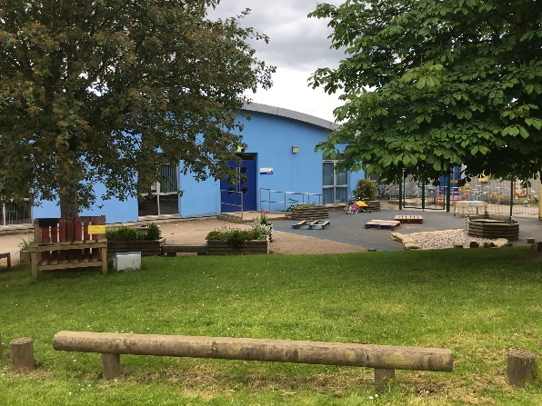
Butterfly Room

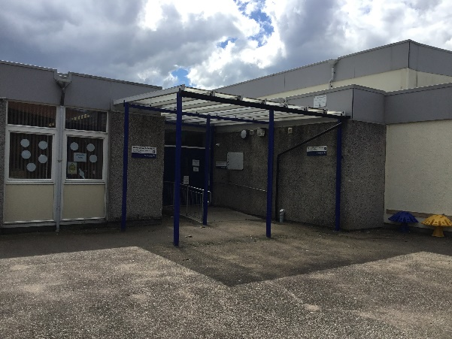
Caterpillar Room

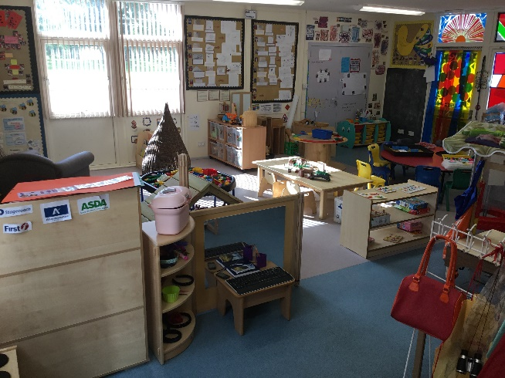
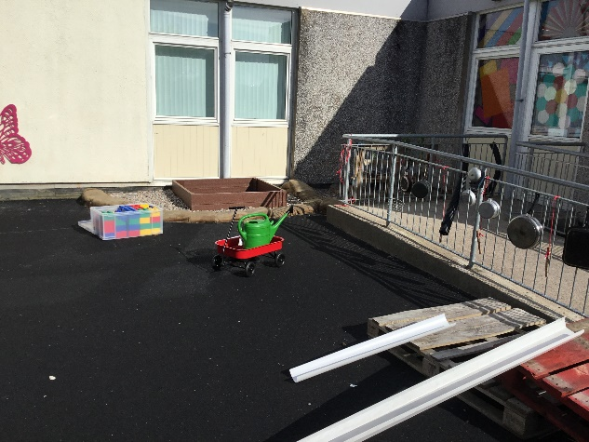

Snack Café and Funding

A healthy snack is provided. The snack menu will be displayed in the Nursery cloakrooms and children are encouraged to suggest new snack ideas. A varied menu allows the children to be tempted to try new tastes and textures.

Snack Café is an opportunity for the children to develop their social skills and have time to talk to each other. They are involved in preparing snack as a snack helper which offers many learning opportunities and a chance to develop a range of skills and encouraging independence.

Special dietary requirements will be discussed at your induction and recorded in your child’s All About Me folder. Special dietary requirements will be observed.

Snack Fees are set at 50p per snack as per Aberdeenshire Council snack policy. This is billed to you by Nursery at the beginning of each term and needs to be paid within the first few weeks. Payment can be made by BACS payment (bank transfer) please use your child’s name as the reference and inform a member of staff of the transaction.
Aberdeenshire Council’s policy is that if your child is absent for the whole of their usual weekly pattern, that their snack fees are refunded by cheque or taken off next terms snack fees.

Nursery Lunch

If your child is attending the morning session till 1pm they will be provided with a free nursery lunch a 12 noon from a set menu. We prefer that children have a school lunch and ask that if they must have a packed lunch that it is healthy and does not contain chocolate or fizzy drinks. We are unable to store packed lunches in a fridge; it is the parents responsibility to ensure there is a ice-pack in their child’s pack lunch bag.

Please inform us if your child has allergies.

Tooth Brushing

We are part of the NHS Grampian Community Dental Service Tooth Brushing Scheme, Childsmile. This means your child will clean their teeth after lunch. Your child is provided with their own toothbrush which is stored in a brush box. It is presumed that you agree to your child taking part, unless you contact Childsmile directly. We have regular visits and advice from Childsmile.

Nursery Times and Attendance

Even though we work over two nursery rooms we are one nursery. There are recent changes on how the nursery is run due to the introduction of the 1140 hours. Alehousewells Nursery opening times are from 8am – 6pm. You will have already been asked your session choice for your child and will have been given the information regarding the main room your child will attend.
The Butterfly Room will be the room open for early starts and late finishes with the Caterpillar Room open from 9am – 1pm. If your child is attending the Caterpillar Room after 1pm, they will join the Butterfly Room where they need to be collected from at pick up time. This transition is always supported by a member of staff from the Caterpillar Room.

Drop Off and Pick Up Times
AM Drop Off

For those who have chosen the soft start 8am – 9am, your child will be required to be dropped off at the Butterfly Room, Caterpillar children will then be taken to their class for 9am by a member of the Caterpillar Room staff.

9am start children can be dropped off between 8.50am and 9am in their respective rooms, doors will be locked at 9am.

PM Pick up / Drop off

Pick up 1pm finish - Doors will be open from 12.50pm – 1pm, please ensure your child has been picked up by 1pm.

1pm start Drop off- 1pm -1.10pm please do not arrive to early as children will be leaving between 12.50pm and 1pm. If you child is starting at 1pm they will not be able to come into nursery till 1pm.

Core session for the afternoon finishes at 4.10pm, the door will be open for pick up from 4pm – 4.10pm.

The Butterfly Room door will be open at those times stated above. If you are late please ring the bell in the cloakroom. The Caterpillar Room entry is via a buzzer system, a member of staff will let you into the nursery and greet you at the nursery door.

All children must be picked up by an adult (over 16 years of age). If your child is being picked up by a stranger to us, please let a member of staff know and write their name on the sign in sheet next to who is picking up my child. If you are delayed and cannot collect your child on time, please contact the school office or nursery room. (telephone numbers on front page).

We appreciate your support regarding drop off and pick up times. It is paramount that the children’s safety comes first.
Safety and Security

The safety of the children in our care is of paramount importance and we strive to ensure that our Nursery is a safe environment.

To maintain a safe and secure environment for our children, strict security is in place. All staff wear identification badges. The nursery door is kept locked except for identified times. Visitors to the nursery are asked to enter via the main school reception where they will be greeted and asked to sign in. Regular visitors to the nursery can sign in at the nursery cloakrooms where we also have visitor badges and sign in sheet.

The small car park at the side of the building is for staff only. Parents are encouraged to use the larger car park at the back of the school building. Make sure your child is always closely supervised when approaching and leaving the Nursery building.
Children should be brought to nursery by a responsible adult (over 16 years old), your child should be handed over to a member of nursery staff.

When entering and leaving the outdoor Nursery entrances please ensure you close the gates properly, ensuring the level is in the lock position. As we use our outdoor classroom/ gardens regularly, walking through the large nursery garden is prohibited between the hours of 8am and 6pm unless you are dropping off or collecting you child from the Butterfly Room. You can NO longer walk through the nursery garden to get to the school reception. You MUST go around the pavement to access the main school building.

Please do not be offended if you are asked by staff to go around the path. Please advise other friends and family members of this new practice.

Home and Nursery Partnerships

At Alehousewells we aim to make our Nursery a war, friendly and welcoming environment for both children and their families. Building on the learning which they have already experienced, we strive to stimulate curiosity, resilience, a desire to learn through play and new experiences.

On acceptance of a place in Nursery for your child, you will be invited along to visit the nursery. This will give your child and your family the opportunity to explore the nursery, meet the staff and ask any questions you may have. During this time staff will meet with your child and yourself to complete their Care Plan and find out more about your child, i.e. likes/ dislikes.

We very much operate an open-door policy therefore; it is important to discuss any concerns which you think may affect your child’s learning or behaviour in nursery with staff at the beginning or end of a session. All information shared is confidential.

As part of our nurture ethos for families to support your child’s development. We are always open to suggestions, so let us know if there is anything that you would like to find out more about.

As our planning is responsive to the children’s needs and interests, we use a planning wall in the nursery to evidence the children’s ideas and how we have met their interests. We welcome your input, please take time to look at the planning wall and add your ideas by using a sticky note or informing a member of staff.

We are always evaluating what we do in nursery and thinking about how we can do things better. We will ask yourself and your child what you think about different things by using lolly sticks or sticky notes. Please take time to respond, we really appreciate your thoughts and opinions.

Throughout the year opportunities arise to discuss your child’s development and progress through Parent/ Carer/ Early Year Lead Practitioner/ Early Years Practitioner interviews.

‘Stay and Play’ occurs regularly. This opportunity gives you the chance to stay for part of the session to share their learning experiences with your child. Children very much enjoy having their important people in their lives in nursery and we enjoy getting to know the children’s important people.

Personal Care

Before your child starts nursery, you will be given a Care Plan to fill in which allows the staff to know your child’s individual needs. This will enable us to support your child appropriately within the terms of the Care Plan agreement. This will be kept in their All About Me folder and can be amended as and when appropriate.

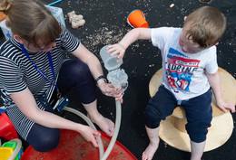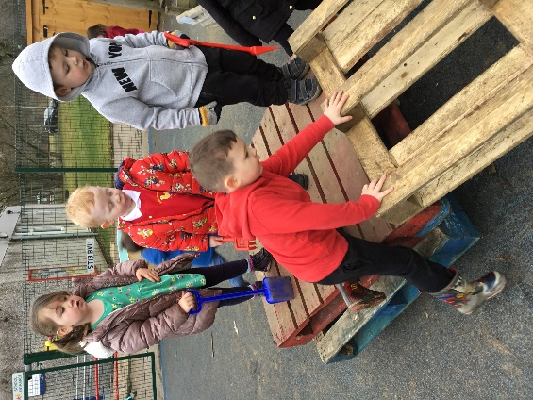

Personal Property / Clothing

It is important your child is dressed in clothes which are easily managed, particularly when this involves going to the toilet or getting changed for outdoors.

Nursery uniform is available from www.abovealldesigns.com
Please note you need to select Alehousewells Nursery

Please provide your child with named indoor shoes as outdoor shoes are changed on entry to Nursery. Each child has their own named peg. Please provide wellies and waterproofs to remain in nursery of possible, we are out in all weathers.

Please label all children’s garments and footwear as many items are identical or similar.

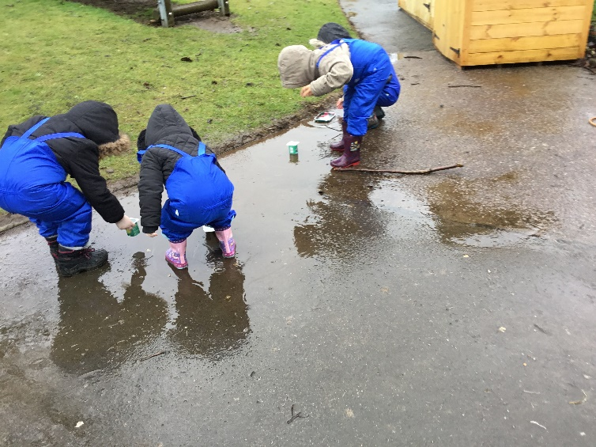
Children should not bring items of value to Nursery; staff cannot be held responsible for any personal items which are lost or taken.

Health Matters

If our child is ill and will not be in Nursery, please telephone the nursery. When your child has been vomiting or had diarrhoea they MUST not return to nursery until they are 48 hours clear from the last bought illness.

If your child become unwell during a Nursery session, a member of staff will contact you. Therefor it is essential that all emergency contacts are up to date.

If your child requires any medication, including inhalers, during Nursery session please ask staff for the relevant medication form, which permits us to administer the medication. Only medication that has been prescribed by the doctor and has your child’s name on the packaging can be administrated by Nursery staff.

Health Advice

See NHS Guidelines Website for most up to date health advice.
www.nhs.uk/livewell/yourchildschool/pages/illness.aspx
First Aid
If your child has an accident in Nursery, a member of staff who is trained in first Aid will attended to your child. They will record the injury and the treatment administered. You will be given a copy of this information. In the event of a more serious accident parents/ carers or the child’s emergency contact will be contacted immediately.

Admission to Nursery

Children in their ante pre-school year (3-year olds) and in their immediate pre-school year (4-year olds) who live in CSN (Community School Network) area may be admitted to our Nursery. Where more applications than available places are received, children will be admitted by the local admissions panel following strict priority criteria. This is accordance with the revised Aberdeenshire Council Education, Learning and Leisure policy, a copy of which is available from the school office. Enrolment for the following session normally takes place during February.

Under the revised Aberdeenshire policy parents of anti-pre-school children still need to apply for a pre0school place if they are returning to the same setting. There are several places for 2-year olds who meet the criteria. Application forms can be obtained for the Department of Work and Pensions or by contacting the Early Years Team at Aberdeenshire Council on 01224 664026, or from the web site www.aberdeenshire.gov.uk/schools/information/early-learning-and-childcare-information

Beginning Nursery

In August children are gradually admitted to Nursery over the course of 1/ 2 weeks depending on numbers and individual needs. Returning children are admitted first.

Data Protection

On admission to Nursery we will seek your permission to use photographs/ video recording for the purpose of internal assessment and display. You will be required to sign consent forms which comply with current GDPR (General Data Protection Regulation).

Insurance

No insurance cover is held by Aberdeenshire Council to provide automatic compensation to pupils in the event of personal accident or death. It is your responsibility as a parent/ carer to insure your child for personal accident or death if you feel this is appropriate.

The Council does hold third party liability insurance, which indemnifies the Council from claims from third parties (e.g. parents of pupils) who have suffered injury, illness, loss or damage arising from the negligence of the Council or it’s employees. However, if there were no negligence, no claim would be accepted by the Council.

Getting Ready for School

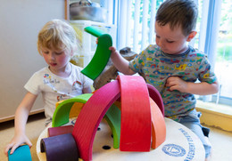

New entrants to P1 are enrolled in January for entry for the following August. This is for children who will be five in or before August. Those whose fifth birthday is between the 1st September and 28th February of the following year may also be admitted to P1. Details of enrolment dates are advertised in the local press by the Authority each January.

Parents wishing to enrol their child are welcome to the school at any time. It is advisable to let us know when to expect you so that someone can be available to show you round discuss any queries you might have. As a setting we are very involved in school life and children will be transitioned throughout the school year by having joint sessions with Primary one and Primary 6.

In accordance with the Aberdeenshire Council pre-school policy there is an opportunity for entry to school to be deferred. This applies to children with January/ February birthdays. Children with additional support needs can also request a delayed entry. If you have any concerns about your child, please discuss this with the Nursery staff.

Child Protection

Everyone has a responsibility to protect children from harm. School and Nursery staff are in a unique position to contribute to the protection of children and must share concerns with appropriate colleagues and agencies.

Every school has a Designated Child Protection Officer (DCPO) who has been specifically trained to listen to concerns and act on them as necessary. In Alehousewells Nursery it is the Early Years Senior Practitioner and Head Teacher. Unless satisfied that a child has not been harmed or is at risk of being harmed, the nursery/ school must relay their concerns immediately to the Social Work service and/ or the Police. Social Work and the Police will determine when and how the child’s parent/ carers and other services are to be informed of the concerns.

Local Social Work Office:
93 High Street,
Inverurie

01467 532888

Comments, Compliments and Complaints

Alehousewells Nursery is committed to delivering a quality service to all our users. We aim to take effective action to ensure standards are upheld and welcome being informed where they have not been satisfactory.

Our Complaints policy is displayed in the Nursery notice boards. We very much welcome comments about our service and how we operate, we continually evaluate our practice. We encourage parents to post comments on our How Good is Our Learning tree as well as responding to questionnaires and You said we did questions.

Aberdeenshire Council policy on Comments, Compliments and Complaints can be found on at www.aberdeenshire.gov.uk or a copy can be obtained from the school office.

We are regulated by the Care Inspectorate who can be contacted by:

Telephone: 0345 600 9527. Email: enquiries@careinspectorate.com.
www.careinspectorate.com

Thank you for takin the time to read our nursery booklet.
We are looking forward to getting to know you and your child.
The Nursery Team.

