Jock o Bennachie’s Summer Activities

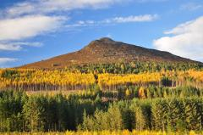

Join Jock online and outside to discover fun facts about nature this summer.
3 freesummer holiday challenges
Birds – starting week 13th July
Things that grow
Mini beasts and pollinators
Each theme will have a small competition
- with prizes!
For full details see: www.bailiesofbennachie.co.uk

