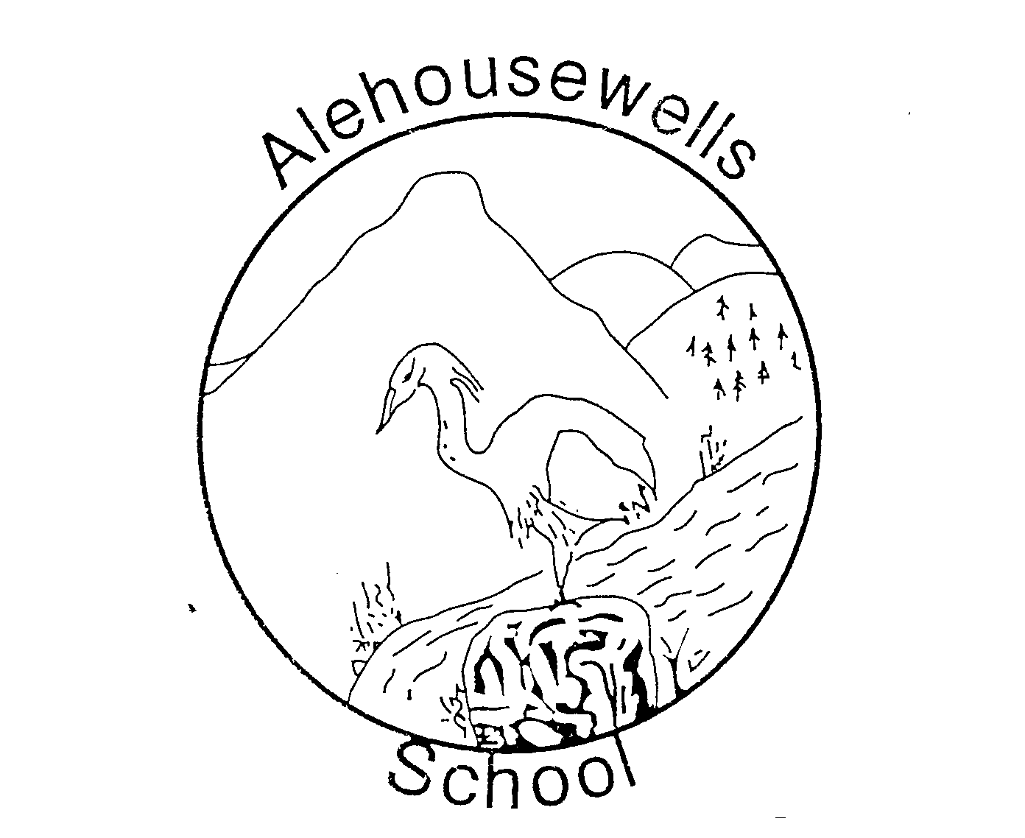

Alehousewells School
Standards & Quality Report
2019 - 2020
&
School Improvement Planning
2020 – 2021

School Forward

We are pleased to present both our Standards and Quality Report for Session 2019– 2020 and our School Improvement plan for the current session 2020 -2021. This report forms part of our quality improvement framework and provides important information regarding our school’s progress to date and identifies our next steps in school improvement.
Self-Evaluation for Self-Improvement is at the heart of our practice in Alehousewells school. We continue to develop our practice in making robust use of evidence as a basis for judgements regarding the impact of our work on our learners.
How are we doing?
How do we know?
What are we going to do now?
Looking inwards to analyse our work
Looking outwards to find out more about what is working well for others locally and nationally
Looking forwards to gauge what continuous improvement might look like in the longer term
At Alehousewells School we continue to be committed to working closely with our community and all other stakeholders that support the education we provide. Together we are working hard to ensure all our pupils get the best possible start in life and are enabled and encouraged to maximize their potential.
We realise that within education things never stand still or stay the same. We continue to strive to meet the changes and challenges. Through this document we hope that you will get a sense of our developments, successes and areas for further growth.

Carol Hughes
Head Teacher

The School and its context

Our vision: Alehousewells School aspires to be a safe and supportive learning community, where everyone is respected, and can realise their full potential within a friendly and caring environment.

Our Values are

Alehousewells Primary and Nursery School is situated in the village of Kemnay, approximately 17 miles from Aberdeen and 6 miles from the town of Inverurie. The village is in a rural setting and has several shops and businesses. The school is non-denominational. The catchment area includes designated zoning of mainly local authority and some private housing within Kemnay and extends into outlying rural areas. On leaving Alehousewells Primary School, most pupils transfer to Kemnay Academy. The school is very much part of the Kemnay community and there are effective links with Kemnay Academy and the other schools in the cluster. There is an active Parent Council who supports the school effectively.

The school’s current roll is 140 with a projected roll of 143 for next session. The school roll has remained fairly stable over the last few years. Alehousewells School provides education for children aged 4^{1/2} –12 in primaries 1-7, and from 2-5 in our two Nursery rooms. This session, we have 6 classes. Our team consists of a non-teaching Head Teacher, 6 full time equivalent class teachers, 7 PSA’s, an Administrator, an Admin Assistant, Kitchen Staff, Cleaners and a Janitor (all of whom are part time). Our own teachers deliver P.E. and Health. Our Active Schools Coordinator provides a wide range of additional active and sporting activities for our children. We work closely with a range of support agencies and volunteers to provide the best possible experience for our children. There is a strong collegiate ethos between staff and a culture of learning and school improvement. The school benefits greatly from parental involvement through the Parent Forum and volunteers.

Data
The majority of our pupils (60%) are in decile 5, based on the Scottish Government data from November 2019.
Less than half of our pupils (16%) receive Free school meals.
A few (11%) pupils’ attendance is less than 90%.

Overall strengths of the school: Here at Alehousewells School, we have a lot to be proud of but in particular we have noted the following key strengths:

- Effective collaborative working practices and collegiality across the school
- Our continued improved approaches to reporting progress to parents
- High quality Nursery provision, particularly the environment and staffing
- Our positive and welcoming ethos throughout the school.
- Pastoral care of the children.
- Mental health and well-being of the children and families
- Working in partnership with families.
- Timely intervention to support educational and health outcomes.

Impact of our developments
In this section we will outline the Targets we set last session and identify the progress we have made during session 2019-2020.
Key priority 2019-2020 | Key actions undertaken | Impact (achieved throughout 2019-2020)
Review and improve Numeracy practises to ensure challenge and progression in the curriculum and improved attainment. | Whole staff involved in review of current Numeracy practises.  Key areas for focus agreed- staff training on Numicon and Sumdog.  Liaised with Nursery to ensure progression starts there. | All staff attended Numicon training in November 2019. Staff increasingly using Numicon with confidence as evident in classroom observations and plans. This includes Nursery children into P1.  Pupils’ number bonds more secure as evident from tracking meetings.  Sumdog now used by staff to provide individualised feedback for pupils and pupils’ skills closely monitored by staff.  Further Staff CLPL booked for session 20-21 on Numicon.
Rollout of Emerging Literacy approaches from P2-P7, especially around phonics and spelling and phonological reading books. | All staff involved in training using Highland Literacy website. One unit only completed before lockdown.  Working party formed who reviewed examples of phonological reading books and made recommendations to rest of school staff. | Unit on Emerging Literacy introduction completed. Impact limited due to lockdown as all other units still to be covered.  Preferred Reading scheme not yet available until session 20-21.
Health and wellbeing, including PE, outdoor learning, Nurture and Rights respecting schools award. | Staff training, led by member of staff currently teaching PE 2 days a week, on how to use new equipment purchased. Staff sharing ideas on usage.  Equipment also bought to be used for Playleaders and outside at breaktimes by all pupils.  Outdoor learning arena installed, and use encouraged.  Nurture- some staff attended whole school nurture course and then two attended the targeted nurture course.  Working towards Bronze Rights respecting schools award (RRSA). | Improved opportunities for all pupils for their entitlement for 2 hours of PE a week as seen in classroom observations and plans.  Less behaviour incidents to deal with over breaktimes as children active.  Increased time spent outdoors learning as seen in forward plans.  Main Nurture messages cascaded to all staff. All areas to have a safe space and an emotional check on return to school in August.  RRSA message shared regularly at Assemblies with pupils, with staff and in Newsletters with parents. Working group set up with pupils and staff. Almost ready to claim Bronze award when lockdown struck.

How good is our leadership and approach to improvement?

QI 1.3 Leadership of change
Developing a shared vision, values and aims relevant to the school and its community
Strategic planning for continuous improvement
Implementing improvement and change
Relevant NIF priority: All
Relevant NIF driver(s): School leadership, Teacher professionalism, School improvement
Level of quality for core QI: 3
(HGIOS?4/HGIOELC? 1-6 scale)
How well are you doing?
What’s working well for your learners?
- All staff engage in regular evaluation of progress, and the identification of future priorities.
- There is an ethos of Leadership at all levels in existence across the school.
- All collegiate activities are based upon working towards the outcomes on the school’s improvement plan and provide a focus for regular reflection and discussion on progress made.
- The school has been part of cross cluster CLPL & moderation sessions to support a shared understanding of standards.
- There are opportunities for leadership across the school community with staff, learners and parents taking the lead in a range of projects and initiatives, eg Library and Excellence time.
How do you know?
What evidence do you have of positive impact on learners?
- In nursery, child led learning is used, taking ideas forward and knowing children as individual learners.
- The use of online ILD’s are well established in Nursery where staff, children and parents can engage in record progress and meet individual children’s needs within nursery and home.
- Outdoor learning area installed, Free books for school initiative involving the community, Alehousewells Challenge 500 fundraiser.
- Playleaders, Monitors, Dinner dudes, Task force, Eco group (Acorns), House captains and Buddies.
What are you going to do now?
What are your improvement priorities in this area?
- Continue to explore ways of involving the wider community in self-evaluation.
- The Head teacher is to be more involved in regular discussions and monitoring activities with teaching staff, giving oral and/or written feedback and following up to evaluate progress made.
- A rigorous QA Programme is to be put in place, with staff given regular feedback on the work they do.
- In order to ensure continuous improvement, all teaching staff and PSAs will engage in yearly reviews through Professional Review and Development or corporate Appraisal, as appropriate. Teaching staff reviews are to be conducted in line with the Standard for Registration, giving staff the opportunity to engage in clear, focused self-evaluation leading to clear targets for development over the coming session.
- School and Nursery have both used online Forms to seek feedback from parents, uptake has been promising so will continue to try this over the academic year.

How good is the quality of care and education we offer?

QI 2.3 Learning, teaching and assessment
Learning and engagement
Quality of teaching
Effective use of assessment
Planning, tracking and monitoring
Relevant NIF priority: All
Relevant NIF driver(s): Teacher professionalism, School leadership, Parental engagement, Assessment of children’s progress
Level of quality for core QI: 4
(HGIOS?4/HGIOELC? 1-6 scale)
How well are you doing?
What’s working well for your learners?
- Teachers work together and have a shared understanding of CfE levels. They are now using the Aberdeenshire Progression Frameworks to support this.
- We try to work with the community and make effective links to learning.
- Learners feel safe and secure, and pupil participation is a feature.
- The school has high expectations for all pupils, and staff work hard to provide a tailored curriculum to meet pupil needs.
- Overall, our learners are developing confidence and life skills, resulting from the many opportunities and responsibilities eg. Monitors, Buddies, Task Force, Eco, Play Leaders, Dinner Dudes and Digital Leaders.
- We use a range of teaching and learning approaches to motivate and engage with different learning styles.
- We promote a positive growth mindset and resilience through our school values.
How do you know?
What evidence do you have of positive impact on learners?
- Our values are embedded in everyday school life. Pupils are nominating others for termly Values badges, and this demonstrates the positive impact.
- Pupils have access to PEF funded Pupil Support Worker and Seasons for Growth, which is supporting the children’s emotional needs therefore positively impacting on their learning.
- A positive ethos is evident in each classroom.
- Achievements both in and out of the nursery and school are celebrated in a wide variety of ways.
- All classes are now using digital technology tailored to the individuals learning needs to motivate learners. This has been shared with parents and carers, where possible.
- We are using Tracking, Monitoring and Reporting to identify pupils’ levels to ensure support and challenge for all learners.
- Learners are engaged through the use of new equipment eg for PE and Numicon.
What are you going to do now?
What are your improvement priorities in this area?
- Continue to use Visible Learning approaches from Nursery to P7 and continue to promote a growth mindset across our whole school community, with a view to raising attainment for all.
- Further develop staff confidence in using a wide range of assessment data, including standardised assessment results, to inform planning, target support and ensure challenge.
- Monitor our tracking of pupil’s wider achievements and the impact it is having on individual learners
- More focus on challenging all children to meet their potential.
- We need a more consistent and progressive system for assessment and recording.
- Aim to enhance outdoor learning experiences through use of new outdoor learning arena.
- Continue to work with the children on learning conversations with their peers.

How good are we at improving outcomes for all our learners?

QI 3.1 Ensuring wellbeing, equality and inclusion
Wellbeing
Fulfilment of statutory duties
Inclusion and equality
Relevant NIF priority: All
Relevant NIF driver(s): Assessment of children’s progress, School improvement, Performance information
Level of quality for core QI: 4
(HGIOS?4/HGIOELC? 1-6 scale)

How well are you doing?
What’s working well for your learners?

Everyone in our learning community is treated fairly and with respect, and we place importance on fostering positive, open and supportive working relationships based on trust.

We actively utilise opportunities to promote diversity, and engage in global citizenship through our curriculum, whole school assemblies, focus activities and learning contexts.
- Global citizenship is reinforced through charity work carried out by pupils.

Individual Education plans (IEPs) are in existence for approximately 2% of the school in order to support individual pupils and ensure needs are met. IEPS contain very clear and succinct targets, are regularly reviewed and updated accordingly.

Our Educational Psychologist is used to good effect, addressing concerns and supporting learners within our school. Other agencies including Health provide effective support, in order to reduce barriers to learning. The School Nurse, Childsmile and Pupil Support Service also provide effective support in order to meet needs.

Clear procedures are in place regarding Child Protection. These are annually reviewed, and all staff are involved in this. Staff have received training around GIRFEC, in order to ensure we are working to support pupils appropriately.

The curriculum is differentiated to meet the universal needs of individuals and groups, and technology is used to support learners as appropriate.

PSAs are targeted to need on a priority basis.
- A network Intervention and Prevention Teacher supports learners with complex social/emotional needs and vulnerable learners.
- PEF money is used to effectively target groups/individuals to close the attainment gap.

How do you know?
What evidence do you have of positive impact on learners?

We have a whole school approach to promoting positive behaviour, and sanctions and consequences are consistent throughout the school, with the flexibility to support individuals where necessary.

Where staff identify learners who require support, we respond quickly, accessing available resources, and working closely with partner agencies where appropriate.

The Task Force helps to identify the school’s chosen charity each year.
- Both parents and pupils are involved in formulating an IEP alongside staff.
- Seasons for Growth is supporting the emotional needs of our pupils when they need it.
- There is evidence of Child Protection, with staff centrally recording information to gain a holistic view.
- PSA allocation is responsive to new and developing need.
What are you going to do now?
What are your improvement priorities in this area?

Further develop Visible Learning across the school community; promote learning characteristics.
- Impact of our work on Visible Learning – eg The Learning Pit, Reflective Language, Growth Mindset etc.
- Make the Charity of the year more visible around the school.
- Rethink how PEF money is used as Writing support has not been featured yet this session.

QI 3.2 Raising attainment and achievement
Attainment in literacy and numeracy
Attainment over time
Overall quality of learners’ achievement
Equity for all learners
Relevant NIF priority: All
Relevant NIF driver(s): Assessment of children’s progress, School improvement, Performance information
Level of quality for core QI: 3
(HGIOS?4/HGIOELC? 1-6 scale)

How well are you doing?
What’s working well for your learners?
- Staff routinely plan together across levels and deliver learning collaboratively, where appropriate, with learners in mixed or same stage groups, working together with different members of staff.
- A very effective transition programme from Nursery into P1 exists, maintaining good links with our local early years’ partner providers. COVID did impact on this but we will look again to see if any changes need to be made.
- Pupil Support Assistants have excellent relationships with children throughout the school and work closely with the class teachers to scaffold children’s learning.
- Planning is differentiated to meet individual needs. ASL and PSA time is targeted appropriately and links to the Schools ASN Audit.
- Parents feel well-informed about pupil progress and events in school, and are happy with the accessibility of teachers and the HT.
- The improved approaches to reporting progress to parents has been extremely well received, and we will continue to build on this again this session.
- The school is continuing to develop skills for learning, life and work.
How do you know?
What evidence do you have of positive impact on learners?
- A programme which ensures effective pastoral transition from P7 to S1 is in place, with strong links to the Guidance and ASL teams at the Academy. As a cluster however, we recognise the need to improve upon curricular transition and have begun to address this.
- Effective teamwork across the school and Cluster supports curricular development and CLPL.
- Staff are engaging with Aberdeenshire Progression Frameworks to enhance learning and teaching across the school. Staff have a shared understanding of expected standards in Literacy and Numeracy.
- Effective transition arrangements are in place for all pupils. 1140 hours and eligible twos are available in our Nursery.
- Pupil transitional postcards, where necessary, help establish positive relationships with new teachers.
- IEPS are in existence for pupils, with pupils, parents, class teacher and ASL teacher being involved in the process.
What are you going to do now?
What are your improvement priorities in this area?
- Discuss with the Academy how best to use information that we pass on as part of the Transition process.
- Consider subjects covered at Cluster collegiate meetings to ensure relevance.
- Further develop staff’s understanding of, and confidence in, expected standards in literacy and numeracy, through engaging with the SALs and the benchmarks within the Aberdeenshire Curriculum Frameworks.
- Further develop processes to gather and act upon stakeholders views on their experience of the work of the school.
- Focus on the national priorities of ‘Raising Attainment for All’ and ‘Closing the Gap’ by reviewing the use of available data to rigorously track individuals and plan appropriate, timely interventions.

PEF 2020-2021

Identified gap | 60% of the school population at Alehousewells is in decile 5, with the rest in deciles 7-10 (November 2019).  46 children (34%) are registered for Free school meals. This is an increase of 24 children from last session.  23 children (16%) have an attendance rate of less than 90%. This is an increase of 8 children since last session.
Expenditure | £29,370 – to be used to fund:  Pupil support worker working 15 hours a week to support pupils emotionally.  Family support worker working 5 hours a week to support parents.  Targeted PSA support for 15 hours a week for individuals on Reading, Spelling and Numeracy practise
Expected outcomes | Increased attendance.  Happier families able to participate and support their child in school life eg Homework etc.  Increased attainment, but this may take some time to be seen.
Impact Measurements | Feedback from staff, parents and pupils sought to see if these measures have made a difference via Forms.  Data analysed – attendance rates less than 90%, pupils/families seen but no longer being supported as managing to cope themselves.

Capacity for improvement

School and Nursery staff are fully committed to the principle of continuous improvement. We wish to provide the very best for every child in our care. In this task, we are increasingly advised by performance data, such as pupil attainment data, so we can see clearly ‘what’ we need to improve.
We will continue to look inwards, outwards and forwards to prepare and equip our young people for their future. We will continue to work in partnership with parents, health professionals, and others to ‘get it right’ for every child.

Action plan 1
National Improvement Framework Priorities | HGIOS and ELCC  1.1 Self-evaluation for self-improvement  1.2 Leadership for learning  1.3 Leadership of change  1.4 Leadership and management of staff/ practitioners  1.5 Management of resources to promote equity  2.1 Safeguarding and child protection  2.2 Curriculum  2.3 Learning teaching and assessment  2.4 Personalised support  2.5 Family learning  2.6 Transitions  2.7 Partnerships  3.1 Improving/ ensuring wellbeing, equality and inclusion  Specific to HGIOS 4  3.2 Raising attainment and achievement  3.3 Increasing creativity and employability  Specific to HGIOELC  3.2 Securing children’s progress  3.3 Developing creativity and skills for life |  |  |  |  | Aberdeenshire Priorities:  1. Improving learning, teaching and assessment.  2. Partnership working to raise attainment.  3. Developing leadership at all levels.  4 Improvement through self-evaluation.
- Improvement in attainment, particularly in literacy and numeracy.
- Closing the attainment gap between the most and least disadvantaged children.
- Improvement in children and young people’s health and wellbeing.
- Improvement in employability skills and sustained, positive destinations.
Key drivers of improvement
School leadership

Teacher professionalism

Parental engagement

Assessment of children’s progress

School improvement

Performance Information
Priority 1 : To improve experiences and attainment in Literacy and Numeracy |  |  | Data/evidence informing priority: Attainment reviews. Staff engagement using HGIOS4.
Key actions |  | By whom |  | When? | How will we evaluate impact?  (Measurements of success) |  | Progress
 |  |  |  |  |  |  | On Track
 |  |  |  |  |  |  | Behind Schedule
 |  |  |  |  |  |  | Not Achieved
Engage in CLPL with staff using Numicon. Split into five learning modules, this programme aims to support staff in identifying and addressing gaps or inconsistencies in pupil’s learning, as well as correcting errors and misconceptions from time lost at school.  Review approached to extended writing across the school. Compare what is used currently (Big Writing) with Big Writing Adventures from OUP. Ask pupils for their thoughts.  Launch Skills programme created using consultation with staff, pupils and parents last session. Progression of skills created to support development of skills throughout the school. |  | All staff  All staff  Led by KM, AB and JA. |  | Throughout the session  Throughout the session  January 2020 | Attainment comparison from start of session, in February and again in May.  Attainment review as above.  Ask pupils via Task Force collection of evidence using Wee HGIOS.  Consultation at end of school session with pupils, parents and staff.

Action plan 2
National Improvement Framework Priorities | HGIOS and ELCC  1.1 Self-evaluation for self-improvement  1.2 Leadership for learning  1.3 Leadership of change  1.4 Leadership and management of staff/ practitioners  1.5 Management of resources to promote equity  2.1 Safeguarding and child protection  2.2 Curriculum  2.3 Learning teaching and assessment  2.4 Personalised support  2.5 Family learning  2.6 Transitions  2.7 Partnerships  3.1 Improving/ ensuring wellbeing, equality and inclusion  Specific to HGIOS 4  3.2 Raising attainment and achievement  3.3 Increasing creativity and employability  Specific to HGIOELC  3.2 Securing children’s progress  3.3 Developing creativity and skills for life |  |  |  |  | Aberdeenshire Priorities:  1. Improving learning, teaching and assessment.  2. Partnership working to raise attainment.  3. Developing leadership at all levels.  4 Improvement through self-evaluation.
- Improvement in attainment, particularly in literacy and numeracy.
- Closing the attainment gap between the most and least disadvantaged children.
- Improvement in children and young people’s health and wellbeing.
- Improvement in employability skills and sustained, positive destinations.
Key drivers of improvement
School leadership

Teacher professionalism

Parental engagement

Assessment of children’s progress

School improvement

Performance Information
Priority 2 : To improve Health and wellbeing for our pupils using a Nurturing approach, Rights respecting schools award (RRSA) and a revised Behaviour policy. |  |  | Data/evidence informing priority: Parents feedback on Behaviour policy requiring updating, Nurture is a key approach to supporting the social and emotional wellbeing of our pupils and Aberdeenshire council has this as part of its framework, along with a Rights respecting schools’ approach.
Key actions |  | By whom |  | When? | How will we evaluate impact?  (Measurements of success) |  | Progress
 |  |  |  |  |  |  | On Track
 |  |  |  |  |  |  | Behind Schedule
 |  |  |  |  |  |  | Not Achieved
Several staff attended the Universal Nurture course last session, two of which went on to attend the Targeted Nurture course. The main themes must be cascaded and then set up in our school, initially and emotional check in and a safe space identified in each area.  Next step is the completion of the baseline assessment by staff, which is repeated at the end of the session to see what changes have been made.  One member of staff is to complete the Boxall Profile training then share this with all other staff and use.  Rights respecting schools award. Working party set up last session involving pupils and staff. Were working towards Bronze when lockdown happened. Group needs to complete work to achieve Bronze then continue on to Silver, ensuring all staff, pupils and parents are aware of this initiative and the difference that it makes.  Review interim Behaviour policy set up at the end of lockdown for our return to school. Consult with all stakeholders before amending or adopting. |  | All staff  All staff  SH  JF, LG  All staff |  | By November 2020  By December 2020  By December 2020  By June 2021  By March 2021 | Through observation and discussion with pupils and staff.  Results should show an improvement.  Boxall scoring used to improve outcomes for certain children.  Achievement of Bronze award.  Pupils, staff and parents knowledgeable about this and the impact children’s rights has.  Stakeholders happy with changes as evidenced in consultation exercise.

Action plan 3
National Improvement Framework Priorities | HGIOS and ELCC  1.1 Self-evaluation for self-improvement  1.2 Leadership for learning  1.3 Leadership of change  1.4 Leadership and management of staff/ practitioners  1.5 Management of resources to promote equity  2.1 Safeguarding and child protection  2.2 Curriculum  2.3 Learning teaching and assessment  2.4 Personalised support  2.5 Family learning  2.6 Transitions  2.7 Partnerships  3.1 Improving/ ensuring wellbeing, equality and inclusion  Specific to HGIOS 4  3.2 Raising attainment and achievement  3.3 Increasing creativity and employability  Specific to HGIOELC  3.2 Securing children’s progress  3.3 Developing creativity and skills for life |  |  |  | Aberdeenshire Priorities:  1. Improving learning, teaching and assessment.  2. Partnership working to raise attainment.  3. Developing leadership at all levels.  4 Improvement through self-evaluation.
- Improvement in attainment, particularly in literacy and numeracy.
- Closing the attainment gap between the most and least disadvantaged children.
- Improvement in children and young people’s health and wellbeing.
- Improvement in employability skills and sustained, positive destinations.
Key drivers of improvement
School leadership

Teacher professionalism

Parental engagement

Assessment of children’s progress

School improvement

Performance Information
Priority 1 : To improve experiences for all in returning to school after lockdown and keeping our school community COVID safe and secure moving forward. |  |  | Data/evidence informing priority: Return from lockdown.
Key actions |  | By whom |  | When? | How will we evaluate impact?  (Measurements of success) | Progress
 |  |  |  |  |  | On Track
 |  |  |  |  |  | Behind Schedule
 |  |  |  |  |  | Not Achieved
Regular and transparent communication with all stakeholders of procedures and changes to these, thus offering reassurance and confidence in the safety of how our school runs.  Look out for children, families and staff who are struggling in the return to school. Be quick to step in and offer support, using Pupil and Family support workers, Time to Talk and signposting to other agencies if needed eg Ed Psych, Social work, CLD etc.  Nurturing approaches will help eg the emotional check in will be invaluable in assessing how the children are each day, as well as a safe space should a child need some timeout.  Re-establish Assemblies, albeit virtually, to foster the sense of belonging and alltogetherness, as well as our school values and three new behaviour rules.  Have the Cost of the school day information at the forefront of our minds, pointing parents in the direction of our foodbank outside as well as our free uniform stock and how to access Free school meals and clothing grants.  Apply for chromebooks from Connecting Scotland programme. Assess if any training is required for those who are successful in securing one.  With the removal of Seesaw, an alternative means of communication and profiling will need to be found, especially if we move to a Blended approach as Seesaw was successfully used during lockdown. This may require staff, pupil and parent training in any new system, which may have to be Teams meantime. |  | HT  All staff, PSW, FSW  All staff  HT and all staff  HT and all staff  HT  HT, all staff, PS |  | Ongoing throughout  Ongoing throughout  Established by September 2020  Established by September 2020  Ongoing throughout  By September 2020  By December 2020 | Feedback from stakeholders  Feedback from stakeholders  Observations of pupils in school/discussions with teachers  Consultation with Pupil council (Task force)  Levels of FSM uptake/foodbank and our uniform.  Consultation with relevant families and staff  Consultation with families and staff

Wider Achievements
- P6 took part in The Hills an in Atween. The aim of this project was to discover more about the local river Don and surrounding land – their use by folk over time, the legends, facts, stories, songs. Also, to give the opportunity for youngsters to explore and discover more about their local area and stimulate enquiry as to how best we can respond to what the earth needs now, looking toward to the time to come. Grace Banks, Storyteller, and Sheena Blackhall, author/storyteller, were the driving forces behind this project.
- Learning arena installed in the playground at the start of the session, an initiative driven by the Eco group
- P7 pupil runner up in draw your own Evening Express front page competition during lockdown.
- Chosen charity of the year SAMH. Bring and buy sale run by Task force raising £212.75. Other money raised throughout the year at Church services and Christmas shows also raised £150.80.
- P7 team won the local Rotary Quiz competition for the first time ever. Lockdown prevented them taking part in any further rounds unfortunately.

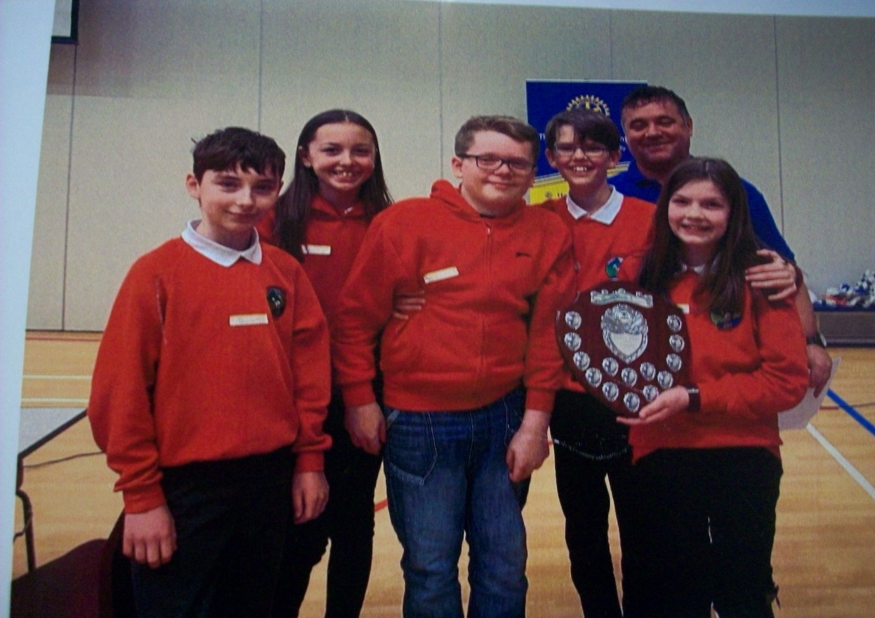
Memories are made of this:

P7 winning Rotary quiz team.
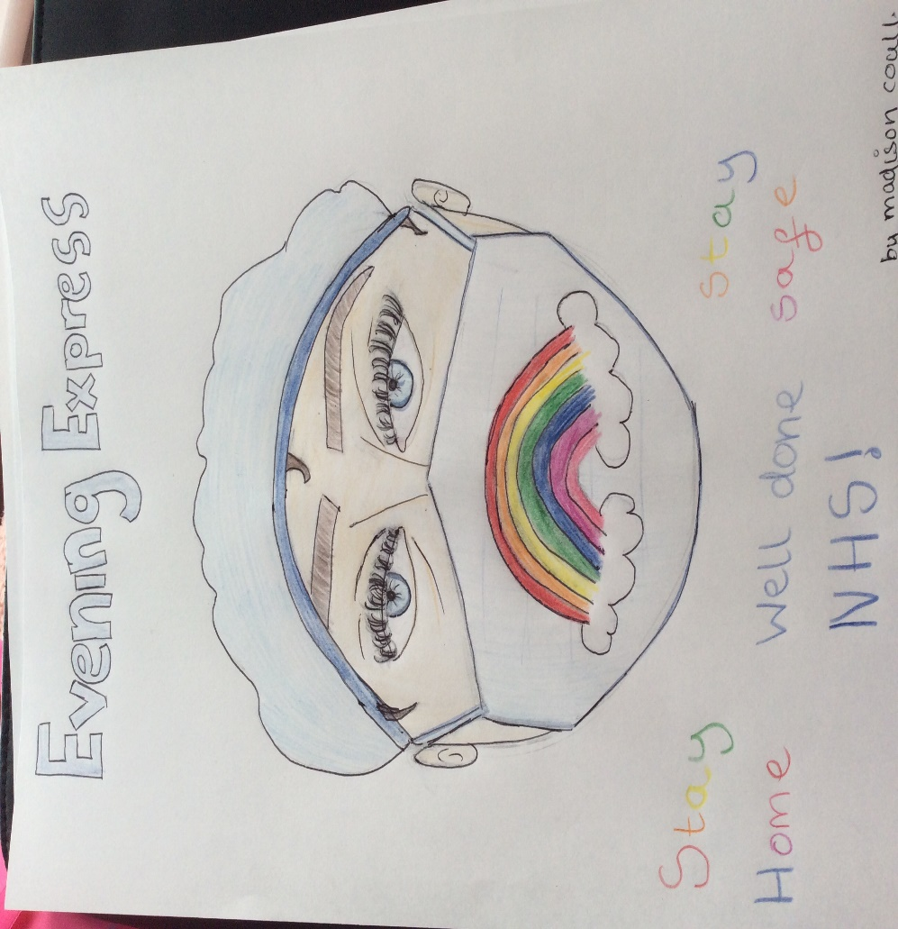
P7 runner up in Design your own front page competition for the Evening Express.
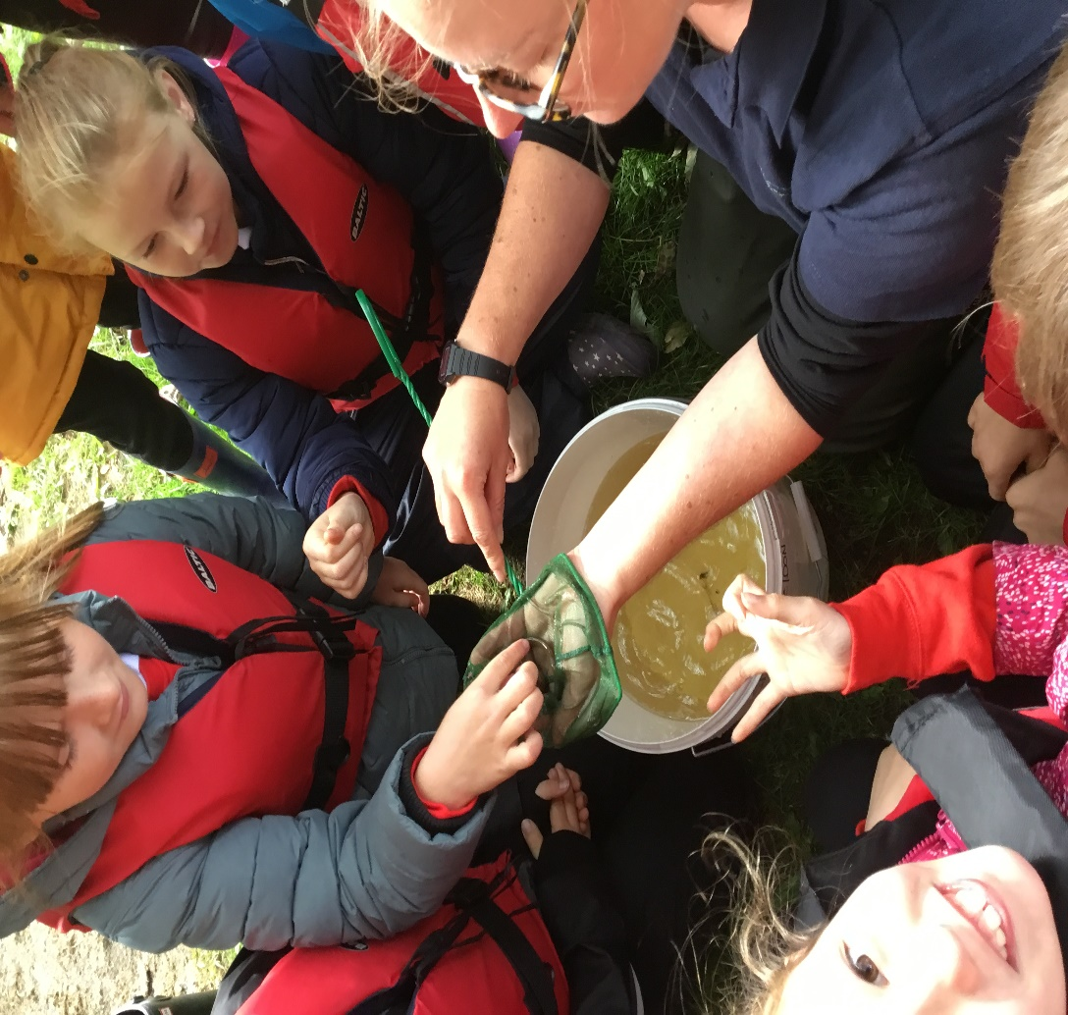
River dipping with the Bennachie Ranger as part of The Hills an in Atween with P6

Wider Community Links

- Local OAPs were invited to the P4-7 Christmas show Holy Joe.
- The choir sang at the Switching on the Christmas lights ceremony in Kemnay.
- Our P7s laid a wreath at the War Memorial on 11 November.
- The local Minister regularly visited school to conduct Assemblies and we attended the Church for our end of term services.
- The Rotary helped with our Christmas fair again.
- We are lucky to get food waste from the local Co-op and are part of the Fare share scheme providing a community food bank to our parents, carers and staff.
- Our Nursery started visiting Littlewood court and the community café in the village hall monthly.
- The local Judo group came in to offer tasters to all in P1-7.

